**WORKING WITH DITA IN OXYGEN ADVANCED PROFILING AND REUSE STRATEGIES**

**1. Conref ranges**

● Conref ranges allow you to create a single referencing element that pulls the content from a range of DITA elements.

● The start and end elements must be of the same type as the referencing element, but the elements inside the range can be of any type.

● Conref ranges are created by using @conrefend in conjunction with @conref or @conkeyref.

● You must have “id” to add those as content reference

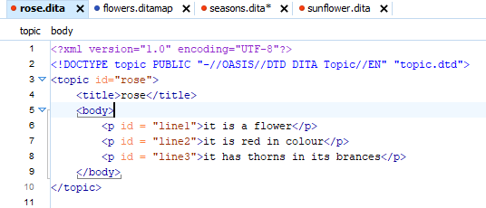

**Steps to add conref ranges**

* Go to option reuse content from menu bar 🡪 select of the dita file whose content reference you want to add 🡪 select the starting line reference from the list

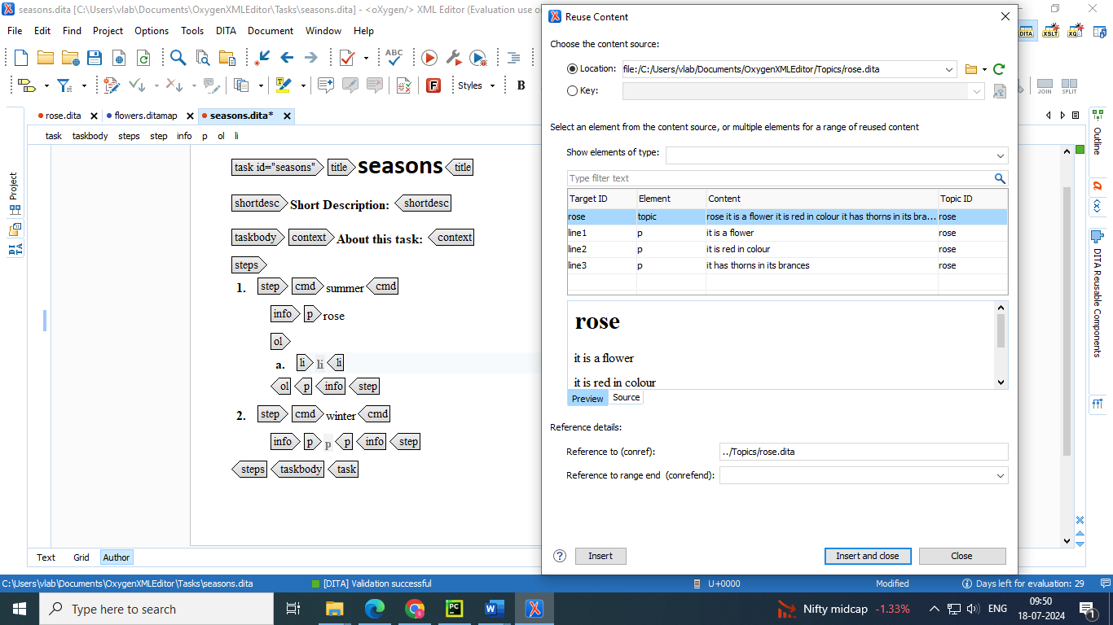

* Go to reference details 🡪 add the range end line reference there

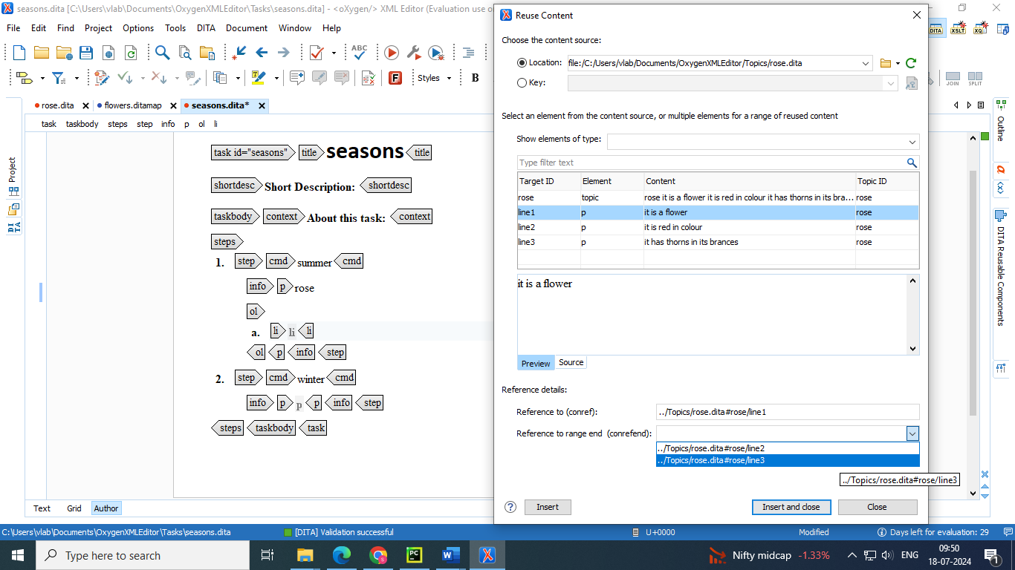

* Insert and close 🡪 you will observe that a single reference is added for all range of lines added

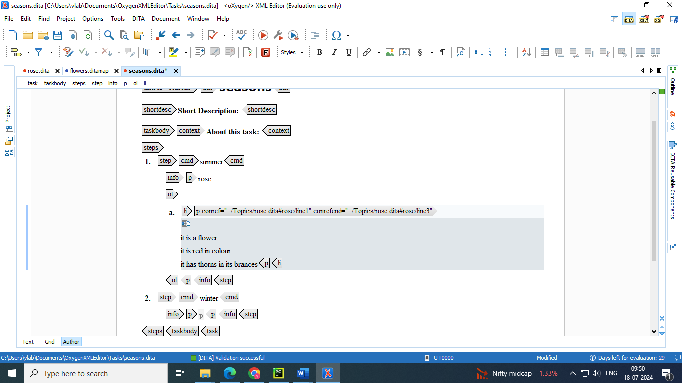

**2. Conref push**

Content Reference Push Mechanism The usual method of using content references pulls element content from a source element and inserts it in the current topic. DITA 1.2 introduced an alternative method of content referencing, allowing element content to be pushed, or injected, from a source topic to another topic without any special coding in the topic where the content will be re-used. This technique is known as a content reference push mechanism (conref push).

The conref push mechanism requires elements in the target topic (the topic where the content is to be pushed) to have ID elements, as the push mechanism inserts elements before or after a named element, or replaces the named element. Assuming the source topic is included in the DITA map, the conref push will be processed during the publishing stage for the DITA map.

● This technique is used to reverse the direction of reuse from pull to push. The content from source topic A is inserted into topic B, relative to a target element that has the @id attribute set on it.

● With a push, the referencing element can be rendered before, after, or in place of the referenced element.

● The push technique is based on the **@conaction** attribute, which determines the location of the reused content.

● Limitation: it is not possible to push a range of elements

**Example of a Conref Push Scenario**

An example of a scenario where a conref push would be useful is where a car manufacturer produces driver manuals that are distributed to various regions with their own specific regulations and certain sections need to be customized by the local car dealers before publishing. The local dealer could use a conref push technique to insert specific content without modifying the manufacturer-supplied content.

**Push Current Element Action**

Oxygen XML Editor includes an action that allows you to easily reference content with a conref push mechanism. The Push Current Element action is available in the DITA menu and in the Reuse subfolder of the contextual menu when editing in Author mode. Selecting this action opens the Push current element dialog box that allows you to select a target resource and element, and where to insert the current element content

**Push action**

Allows you to choose one of the following options for where you want to insert the current element content:

* **replace the target element**
* The target element will be replaced with the current element content.
* On the technical side, the value of the @conaction attribute in the current element will be set to push replace and the @conref or @conkeyref attribute will be set to the specified reference.
* **push before**
* The current element content will be inserted before the specified target element in the target resource.
* On the technical side, the value of the @conaction attribute in the current element will be set to pushbefore. Another element with the same name and class as the target element will be inserted in the document after the current element. The new element will have the @conaction attribute set to mark and the @conref or @conkeyref attribute will be set to the specified reference.
* **push after**
* The current element content will be inserted after the specified target element in the target resource.
* On the technical side, the value of the @conaction attribute in the current element will be set to pushafter. Another element with the same name and class as the target element will be inserted in the document before the current element. The new element will have the @conaction attribute set to mark and the @conref or @conkeyref attribute will be set to the specified reference.

**Steps to push a element from one topic to other**

* Select the tag of the line at which you want push the element from other topic

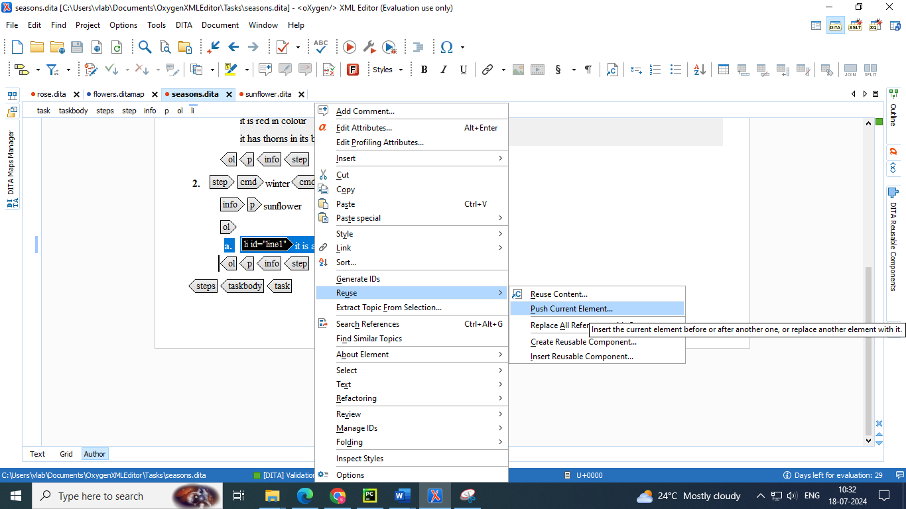

* Select the line from the topic which you want to push it into other topic in 3 ways

1. Replace the target element
2. Push after
3. Push before

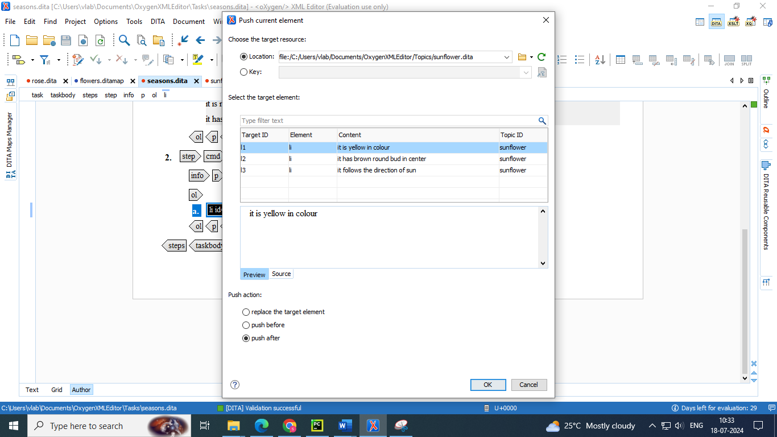

* It adds @conaction tag to elements and pushes before or after or replace element in target topic

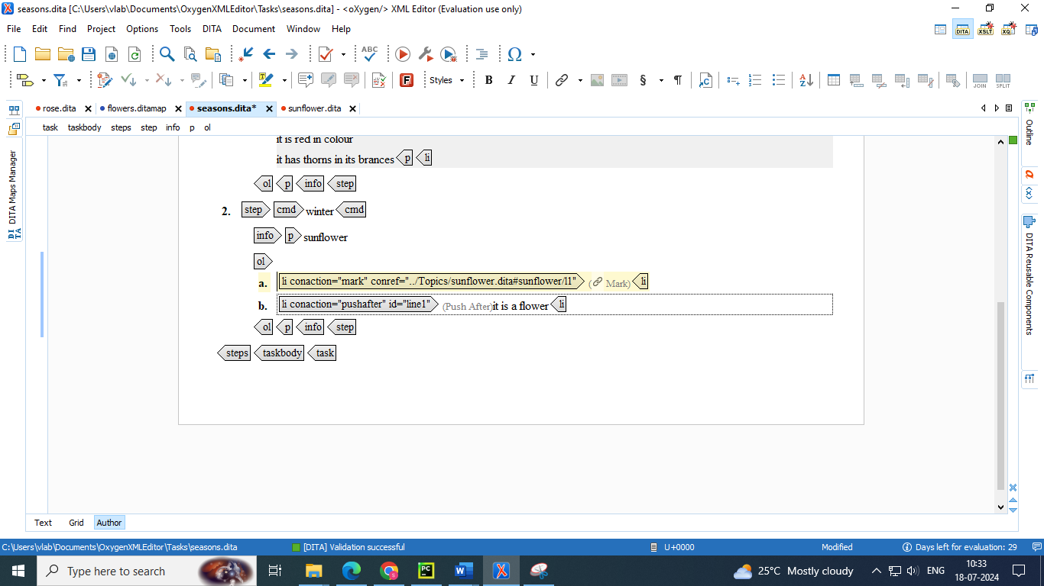

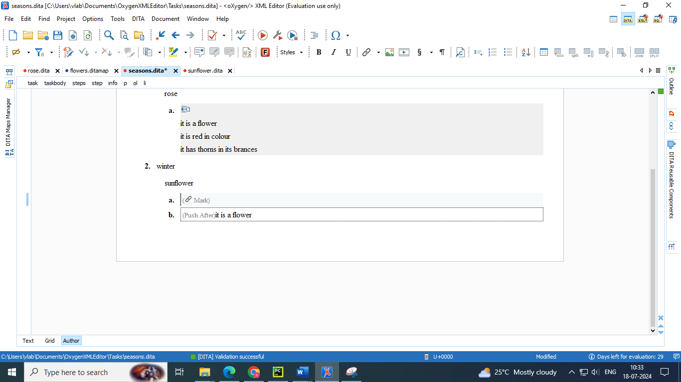

**3. Profiling Attribute Groups**

Conditional processing attributes can be specified using grouped values. Groups organize the attributes into subcategories. This is intended to support situations where an attribute applies to multiple specialized subcategories. For example, suppose a company needs to filter content for several internal teams (operations and support) and they use the @audience attribute with the values ops and support, but the Support team has several levels of personnel (L1, L2, and L3). They could use a group to define the levels (L1, L2, and L3) as subcategories for the support value. Using groups for these subcategories allows each category to be processed independently.

A major advantage is that you do not need to add new profiling attributes You can re-use existing DITA profiling attributes (such as @product, @audience, @otherprops) and specify multiple attribute subcategories.

● Profiling attribute groups are intended for situations where a predefined profiling attribute applies to multiple specialized subcategories.

● E.g. @audience = { general, technician(software hardware) }

● A major advantage is that you do not need to add new profiling attributes using a schema specialization. You can reuse existing DITA profiling attributes (@audience, @product, @platform, @otherprops) and specify multiple attribute subcategories.

**Creating a Conditional Profiling Attribute Group**

To create a group in Oxygen XML Editor:

1. Open the Preferences dialog box (Options> Preferences) and go to Editor > Edit modes > Author > Profiling / Conditional Text > Attributes and Condition sets.

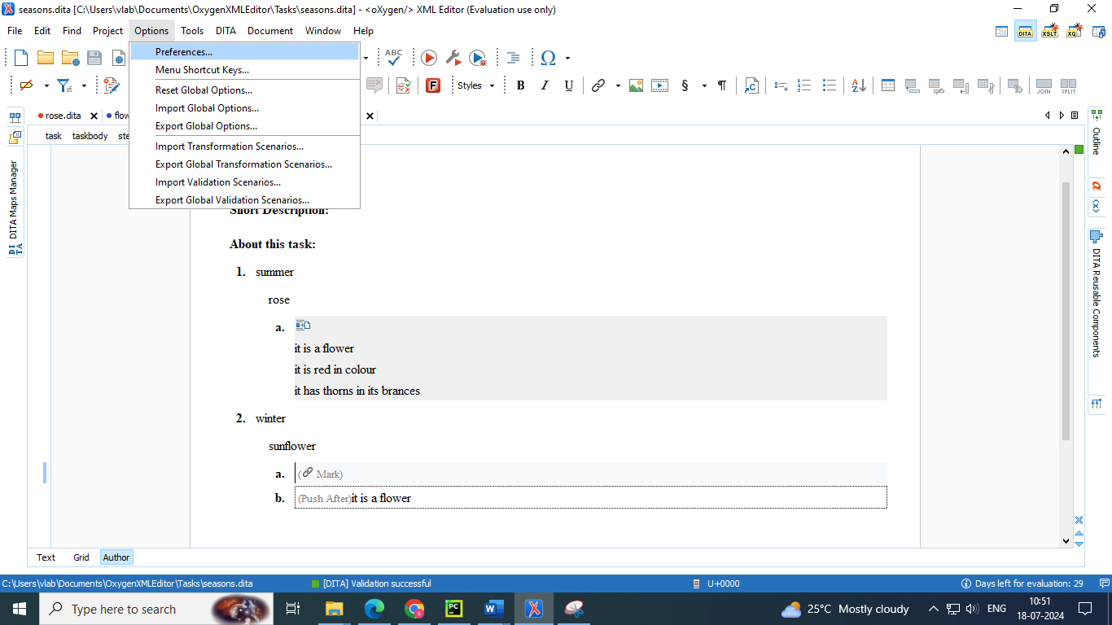

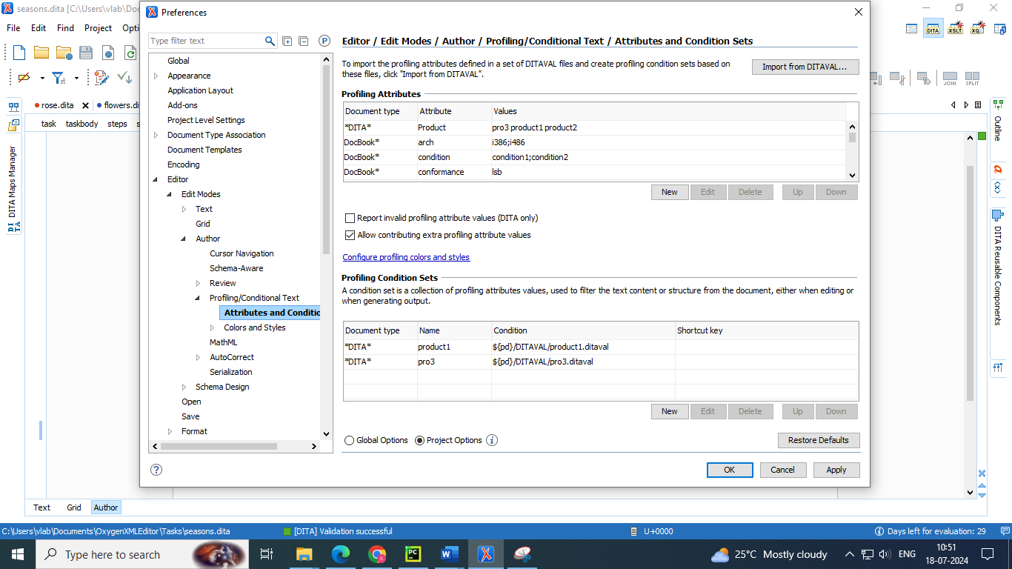

1. To add new attributes and values, click the New button at the bottom of the Profiling Attributes table. To customize existing attributes and their values, select an attribute and click the Edit button.

**Step Result:** In either case, this opens a Profiling Attribute configuration dialog box where you can define attributes that exist in your schema.

3. Specify the appropriate values for the Document type, Attribute name, and Display name. For information about the Profiling Attribute configuration dialog box, see Defining Profiling Attributes for DITA Content

4. Click the New button at the bottom of the attribute values table.

5. In the Value field of the resulting dialog box, define groups using the following format: ParentAttrValue(SubAttrValue1 SubAttrValue2).

For example: support(L1 L2 L3) 6. Click OK and Apply to save and apply the changes.

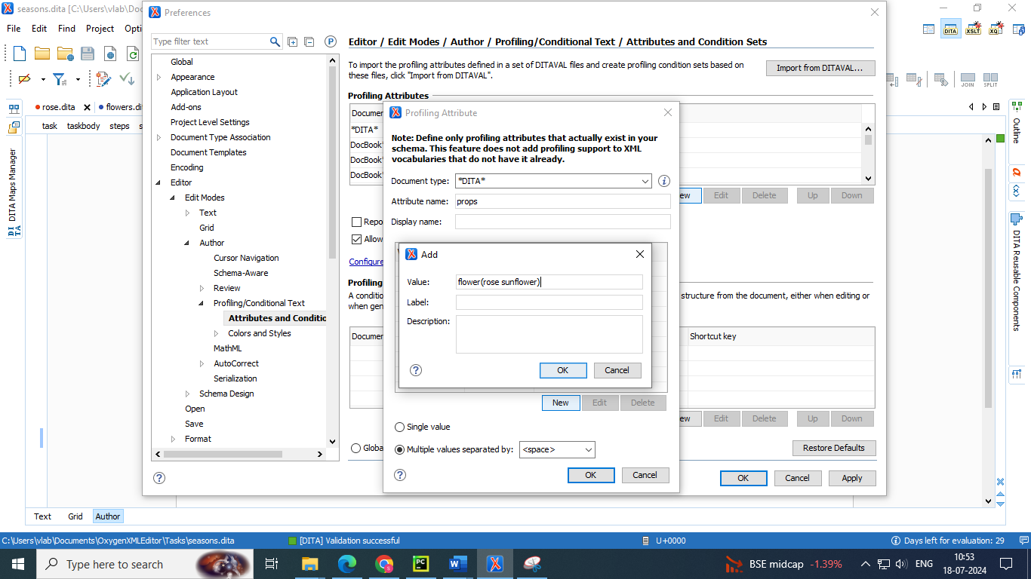

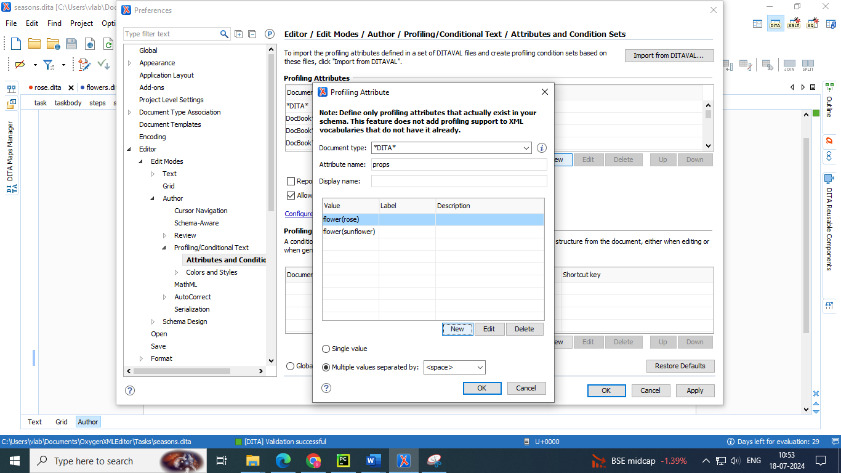

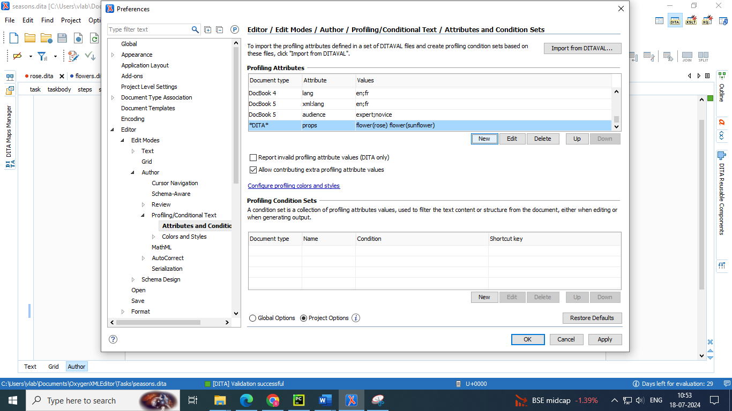

**Applying the profiling attributes groups to topics in DITA map manager**

* Select the topic to which you want to apply profiling attribute sub group 🡪right click 🡪select edit properties

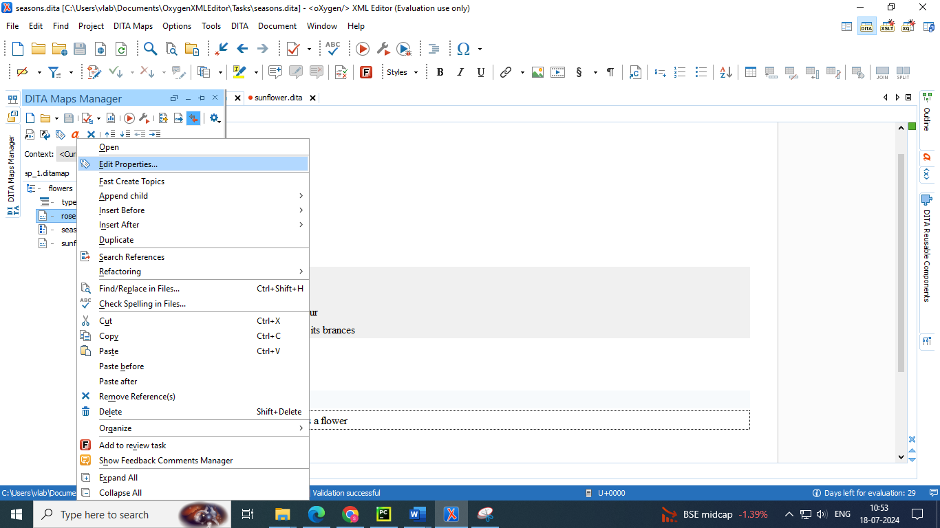

* Apply the required sub category from the attribute group

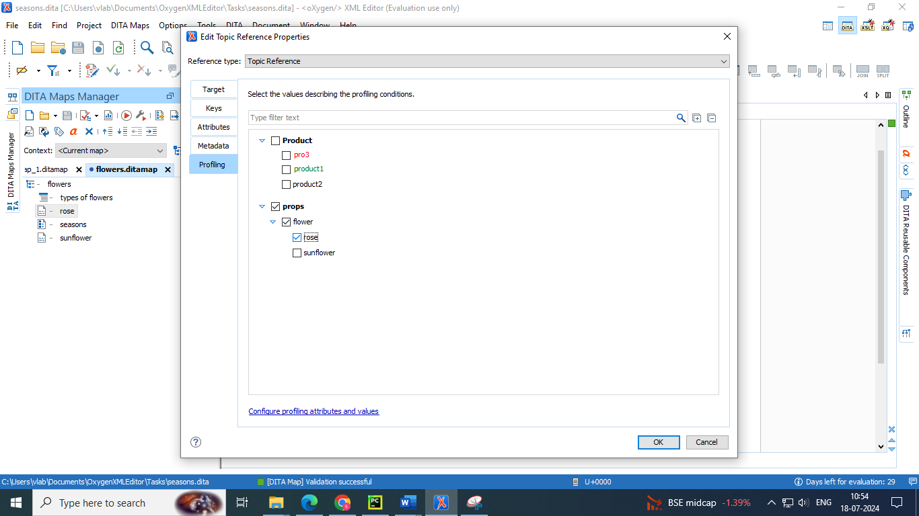

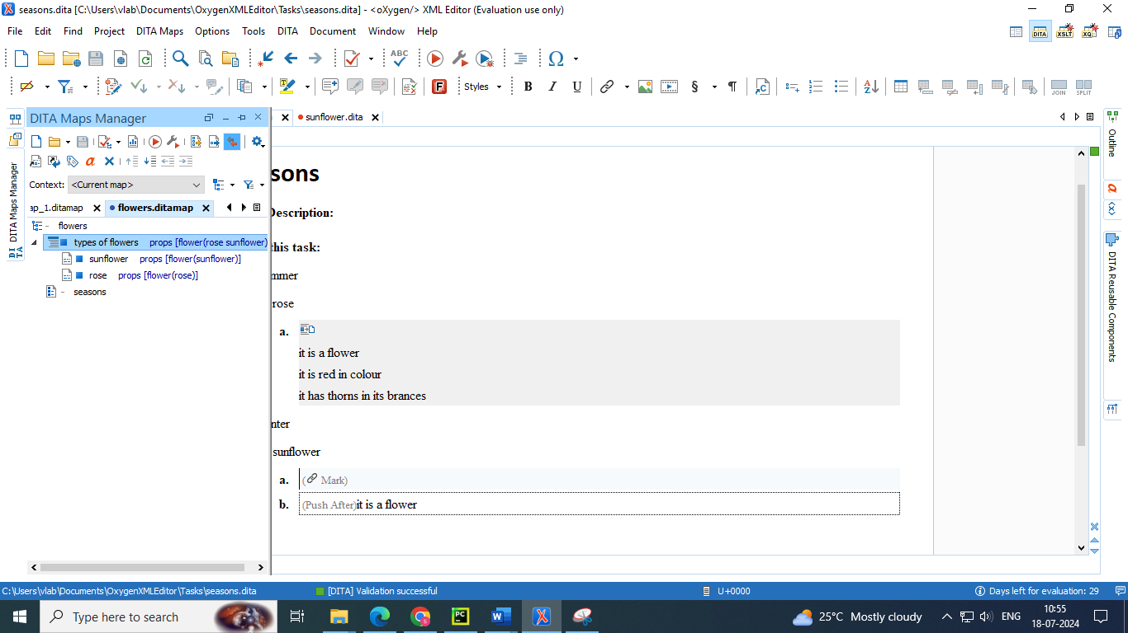

**Using Conditional Profiling Attribute Groups in Conjunction with a DITAVAL File**

* You can use groups to customize a hierarchy of profiling attribute values and then use it in conjunction with a DITAVAL file to filter or flag the values.
* For example, suppose the company described in the example in the Overview section needed to generate content for the Support team, but only for L1 and L2 support personnel
* That DITAVAL file could then be used for a condition set (on page 3326) to filter content in Author mode or during the transformation stage to filter content in the output (on page 3345) and content profiled with the L1 and L2 values would be included while content with the L3 value would be excluded.
* This example company could also have another DITAVAL file for filtering out all content profiled for any of the three subcategories (L1, L2, L3) by simply excluding the support value (since L1, L2, and L3 are subcategories of it).

**Steps to use DITVAL files as profiling attribute groups**

* Create a ditaval file 🡪 go to project file manager 🡪 new 🡪 file

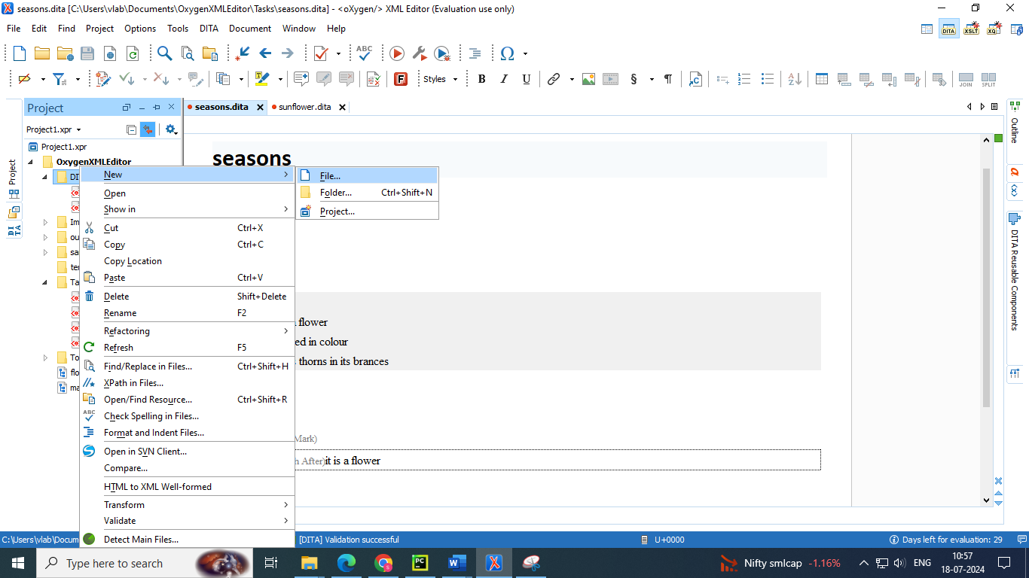

* Select the filter type 🡪 enter a name and save it

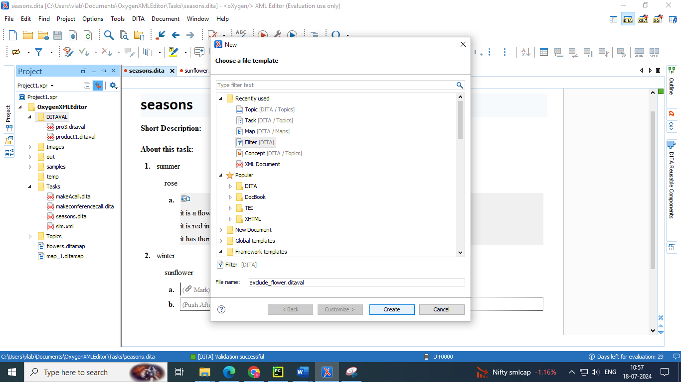

* Example : exclude the attribute “flower” 🡪 enter the below code in ditaval file in text mode

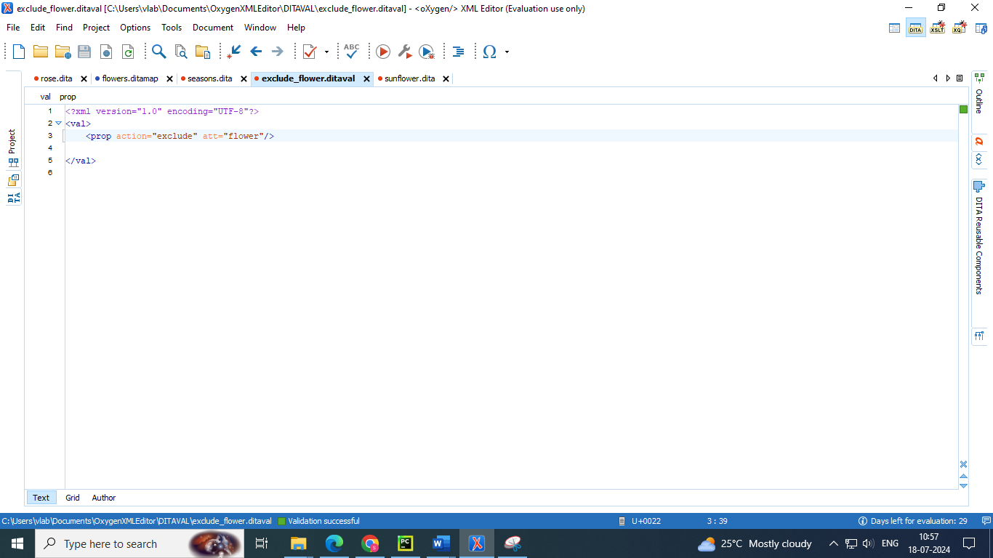

* Add the ditaval file in profiling settings 🡪 profiling/conditional text 🡪 attributes and condition sets 🡪 add ditaval file in profiling condition sets

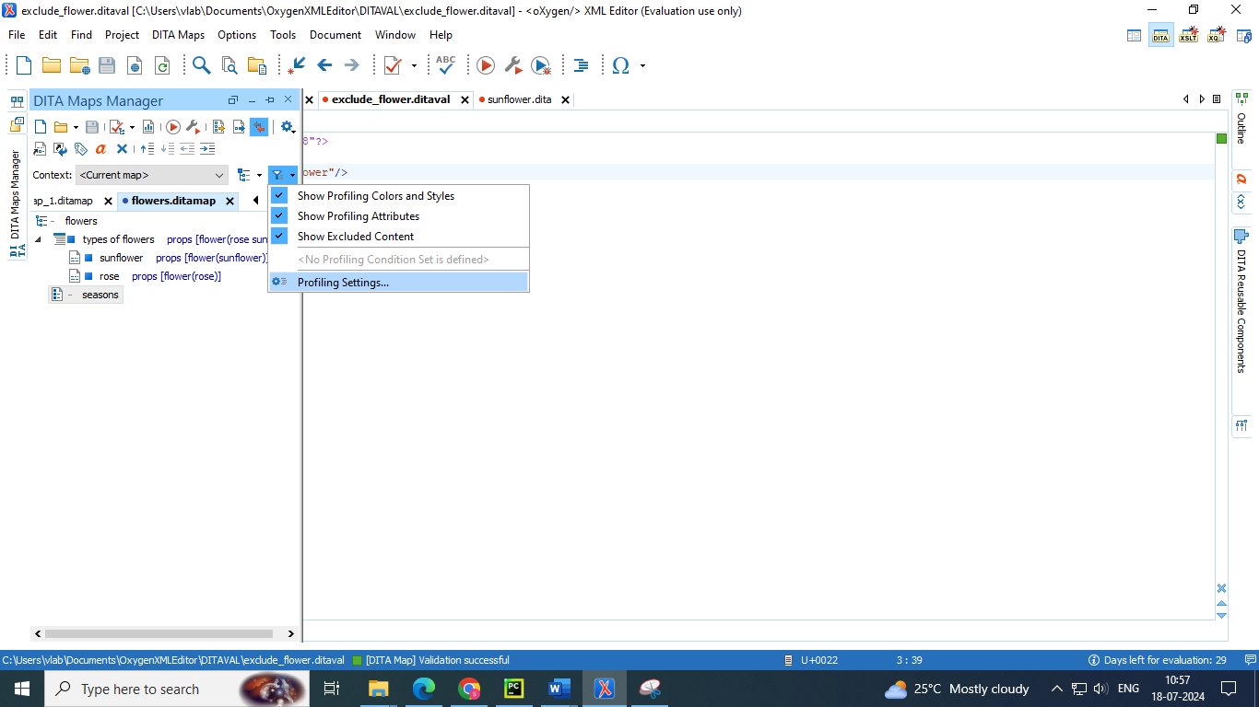

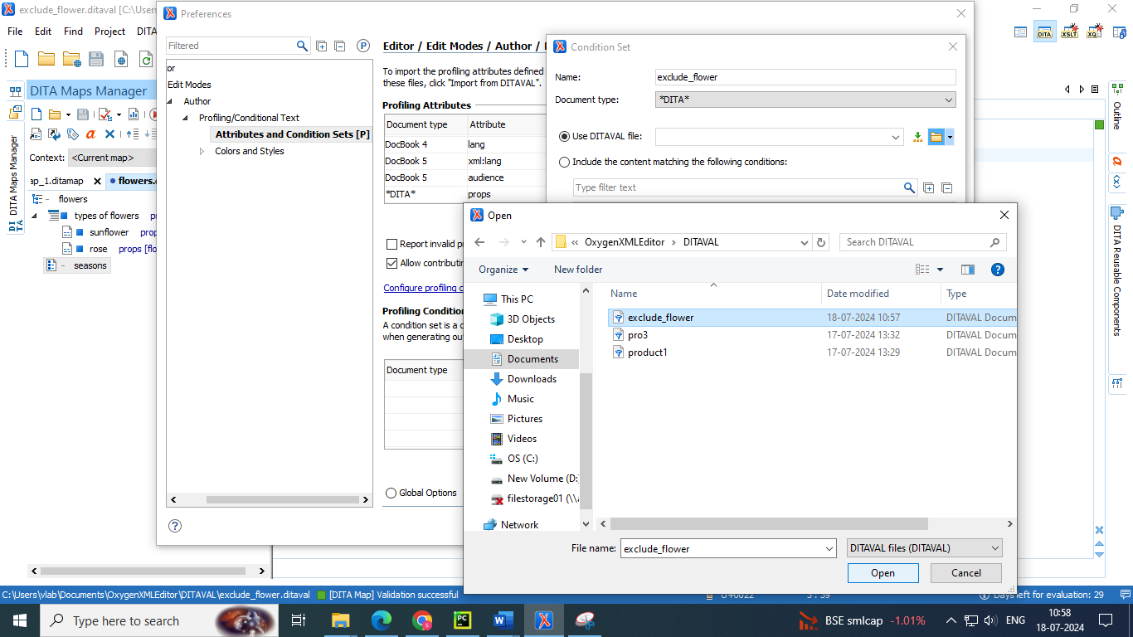

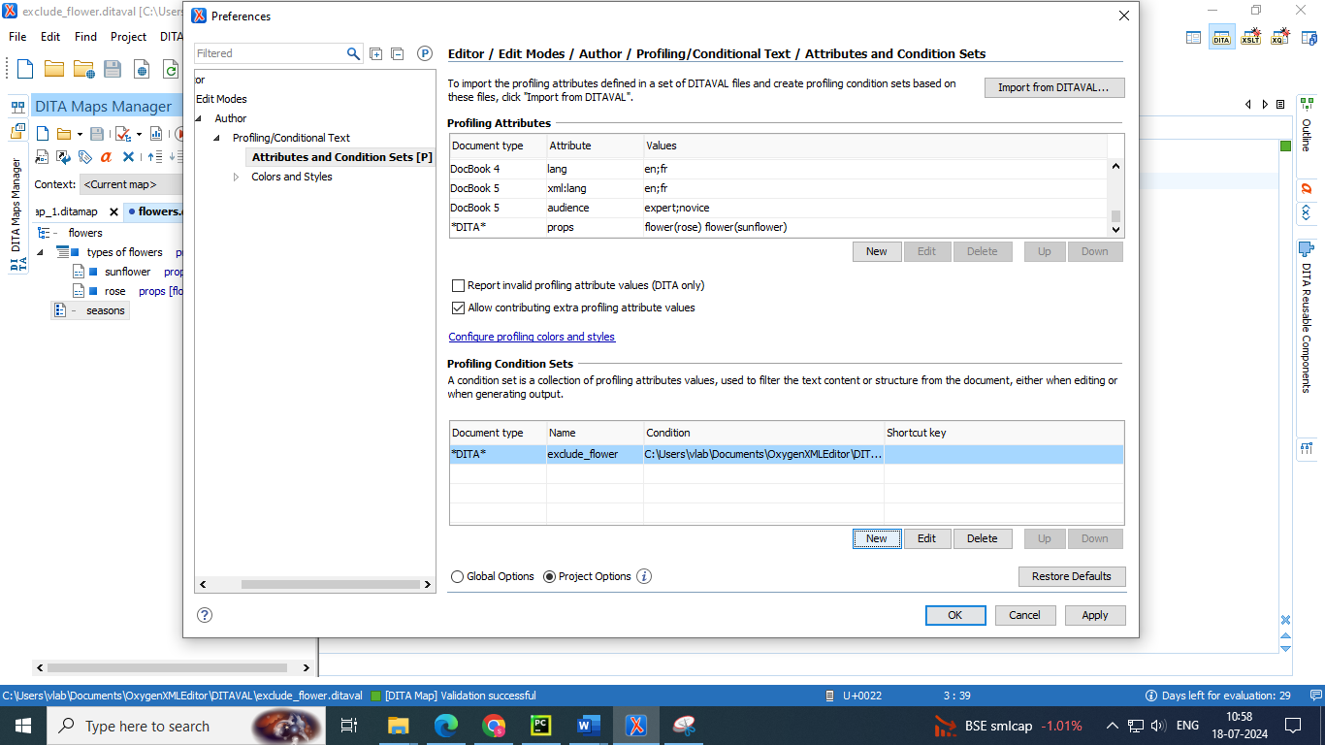

* Apply the ditaval file to the ditamap by selecting the ditaval filter from the drop down of the profiling filters list in dita map manager

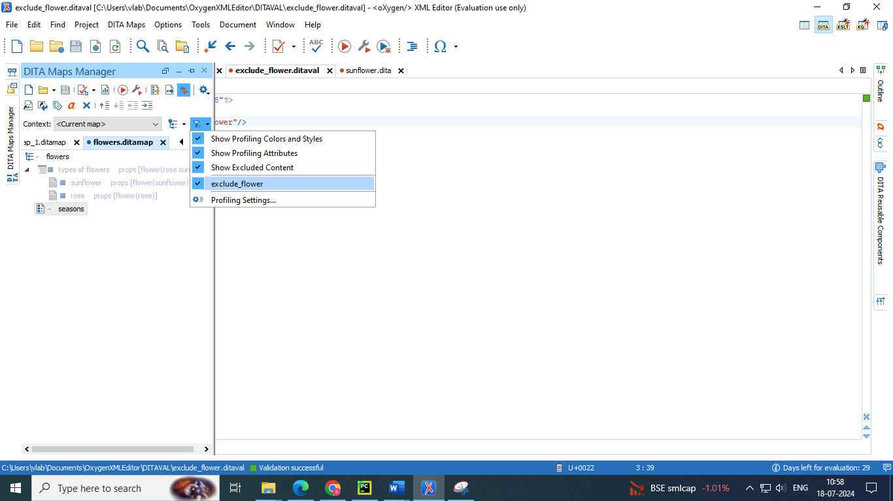

Fig : excluded content is grayed out

* If you want to exclude the subcategory frim the attribute group 🡪 add the “val” in text area code of the ditaval file

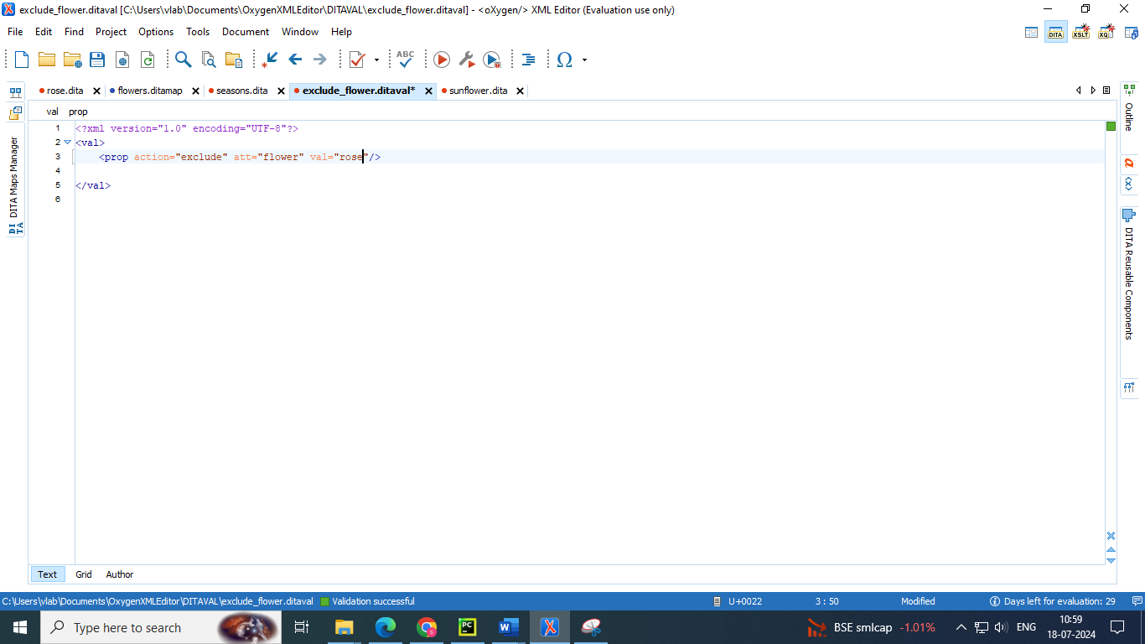

* Reload the files to get the changes of applying only sub category filter

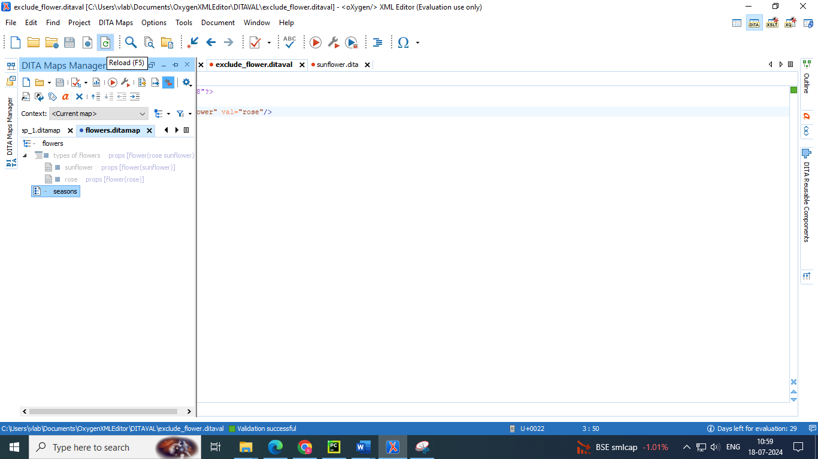

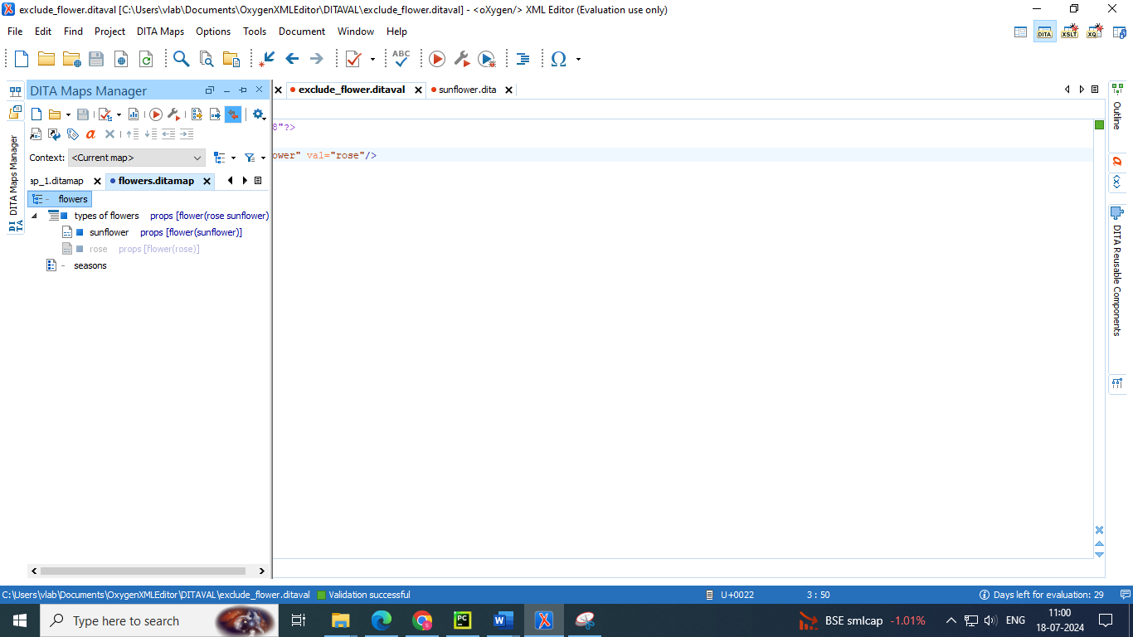

Fig : subcategory of flower : rose is grayed out

* We can enable the ditaval filters checking ion the DITA completeness check

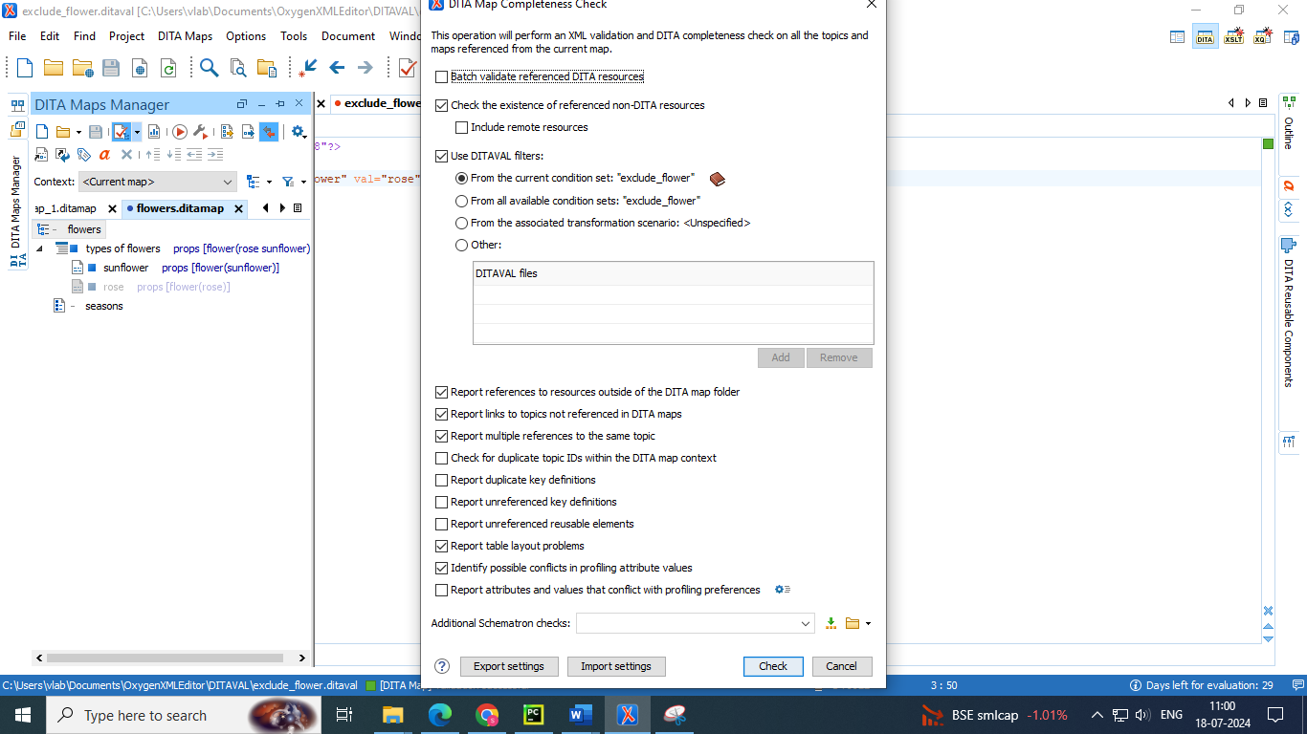

**Subject scheme maps**

A subject scheme map allows you to create and manage custom profiling values in DITA documents without having to write a DITA specialization. Ultimately, this allows you to filter and flag content in Author mode or in transformed output.

Subject scheme maps use key definitions to define a collection of profiling values. You can also use subject scheme maps to filter out (reject) the values for certain attributes so that you only see the attributes or values that you want to use in Author mode or the transformed output

● A subject scheme map is a map specialization used to define sets of controlled values for use in classifying content.

● Sets of controlled values can be bound to DITA attributes, as well as element and attribute pairs.

● The controlled values can be shared without having to modify a schema, just by sharing the subject scheme map.

● One use case of subject scheme maps is to create and manage custom profiling values in DITA documents without having to write a DITA specialization.

**Advantages of Using a Subject Scheme Map**

The advantages of using a subject scheme to control profiling attribute values include:

• You can create a hierarchy of profiling attribute values and use a DITAVAL file to filter or flag the tree of values.

• You can share the subject scheme files with others without having to share preferences or the entire project.

• The subject scheme offers validation support so you are notified if an undefined value is used.

**Creating a Subject Scheme Map**

To create and configure a subject scheme map, follow this procedure:

1. Use the New Document wizard to create a new Subject Scheme document (Framework templates> DITA Map > map> Subject Scheme).

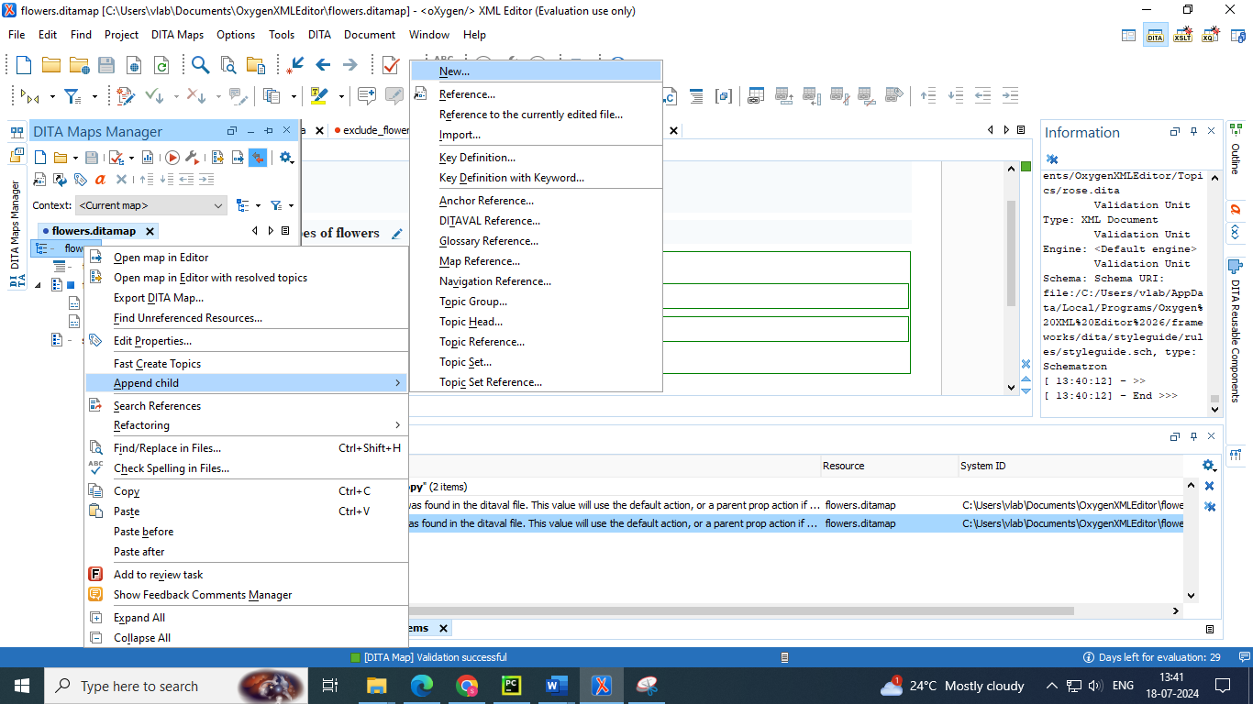

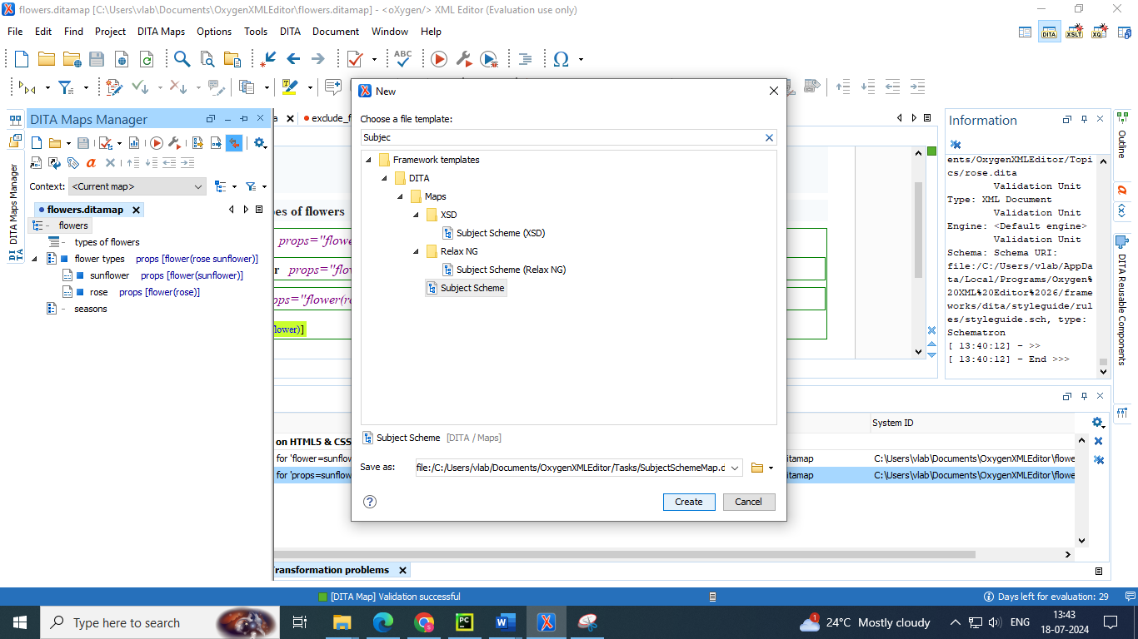

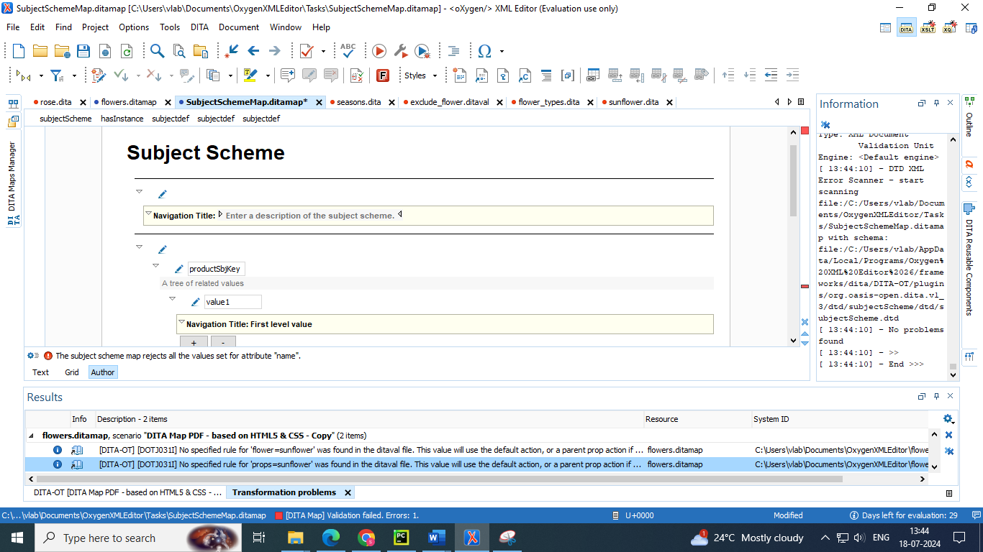

2. Use the controls in Author mode to define the hierarchical tree of values for your subject scheme (see the Author mode example below )or switch to Text mode and define it there if you prefer (see the Text mode example below )

3. Bind the particular attribute to the key you define for the tree of values using the and elements inside the element. Notice that in the examples below , the audience attribute is bound to the audienceKey value.

4. If you want to filter out (reject) values for certain attributes, bind the attributes to a blank value (as you see for the props and otherprops attributes in the examples below This means that those attributes will not appear in the various places where profiling attributes are presented in Oxygen XML Editor

5. Save your subject scheme file.

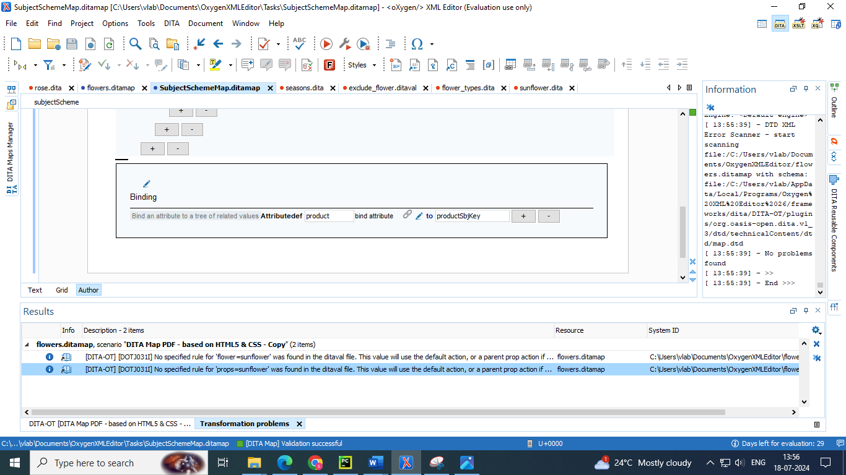

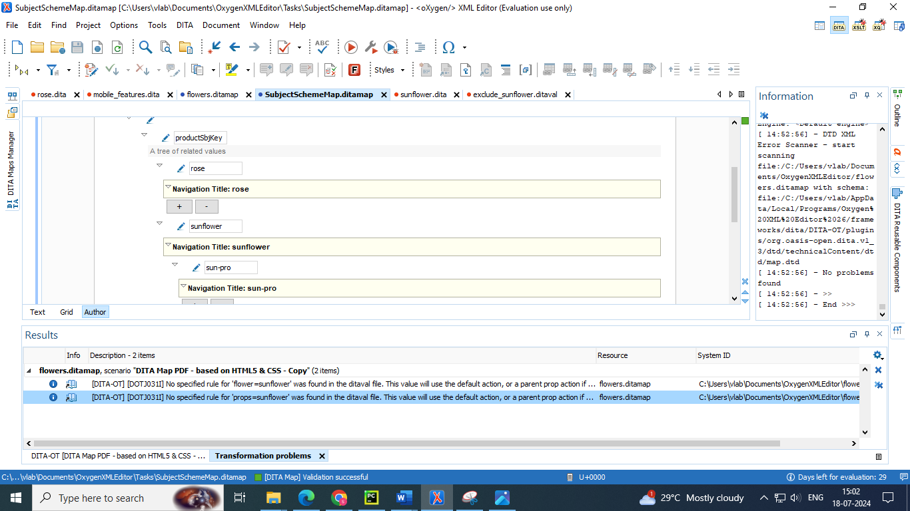

Fig : sun-pro is subcategory value of sunflower due to the indentation we have kept

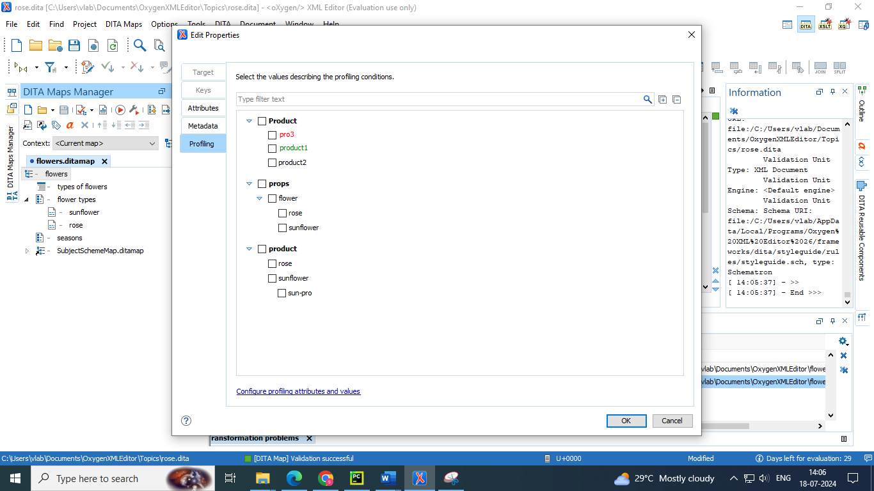

* Add the created profiling attributes through subject schema map to the matter in the topic

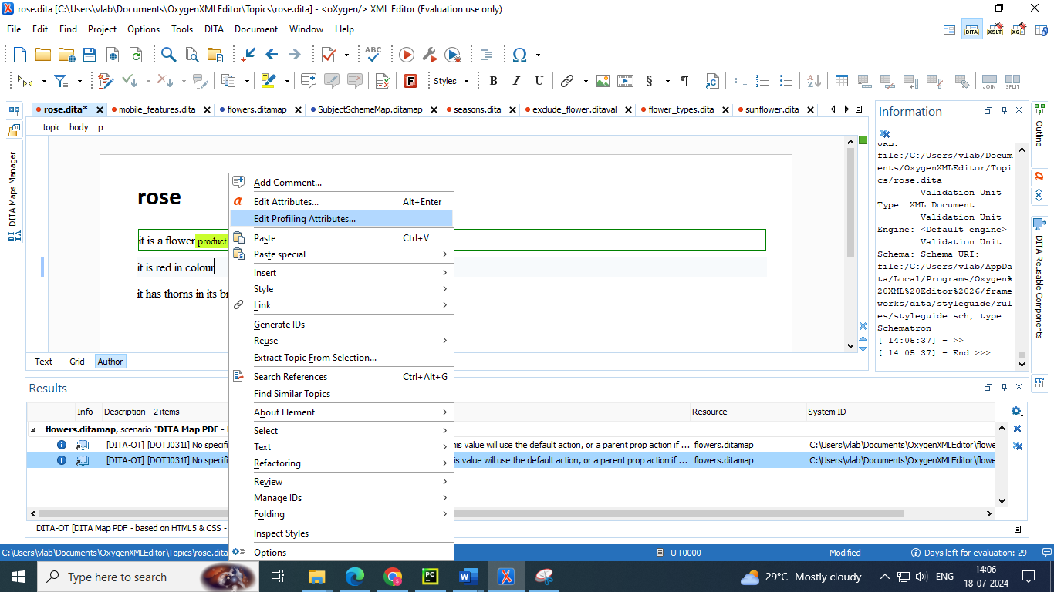

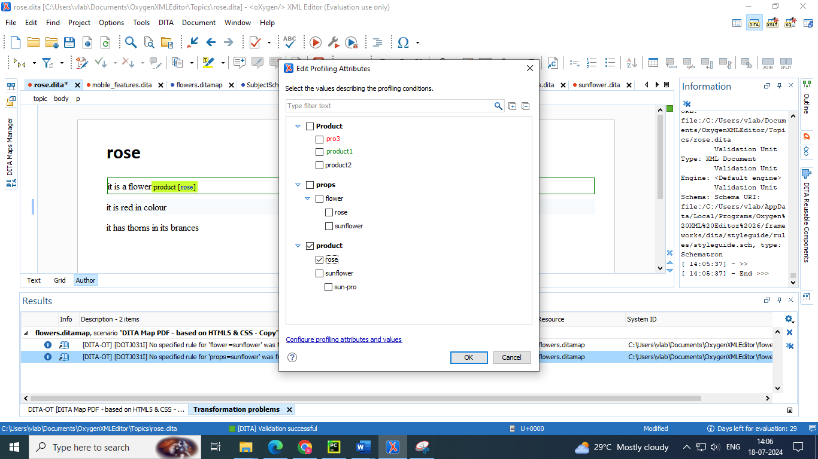

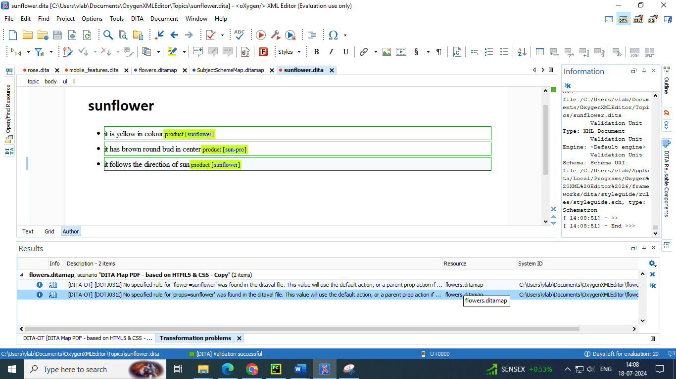

**Using a Subject Scheme in Conjunction with a DITAVAL File**

You can use a subject scheme to customize a hierarchy of profiling attribute values and then use it in conjunction with a DITAVAL file to filter or flag the entire tree of values

That DITAVAL file could then be used for a condition set to filter content in Author mode or during the transformation stage to filter content in the output

* File 🡪 new 🡪 create a DITAVAL file (Filter)
* Enter the attribute and value name at “att” and “val” values which you want to exclude

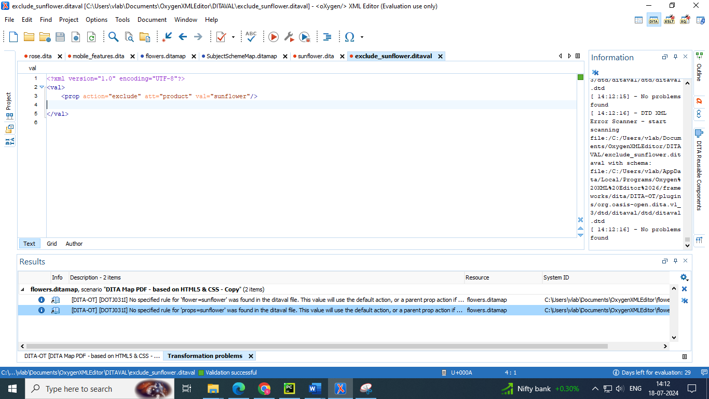

* Go to DITA map manager 🡪 profiling settings 🡪 attributes and condition sets 🡪 add the DITAVAL file created to exclude “sunflower” in the profiling condition sets

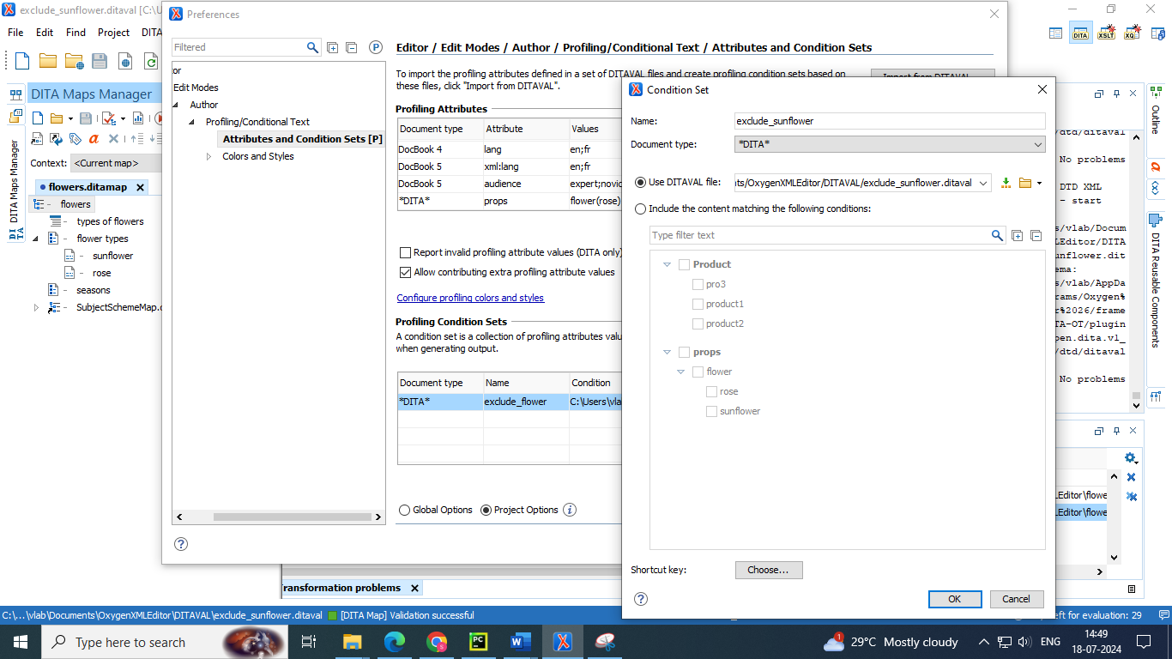

* Apply the exclude_sunflower ditaval file

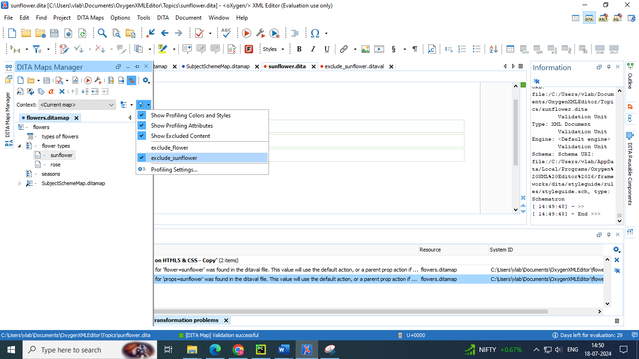

* We will find the subcategory of sunflower that is “sun-pro” is also excluded (grayed out) because it is subvalue of sunflower

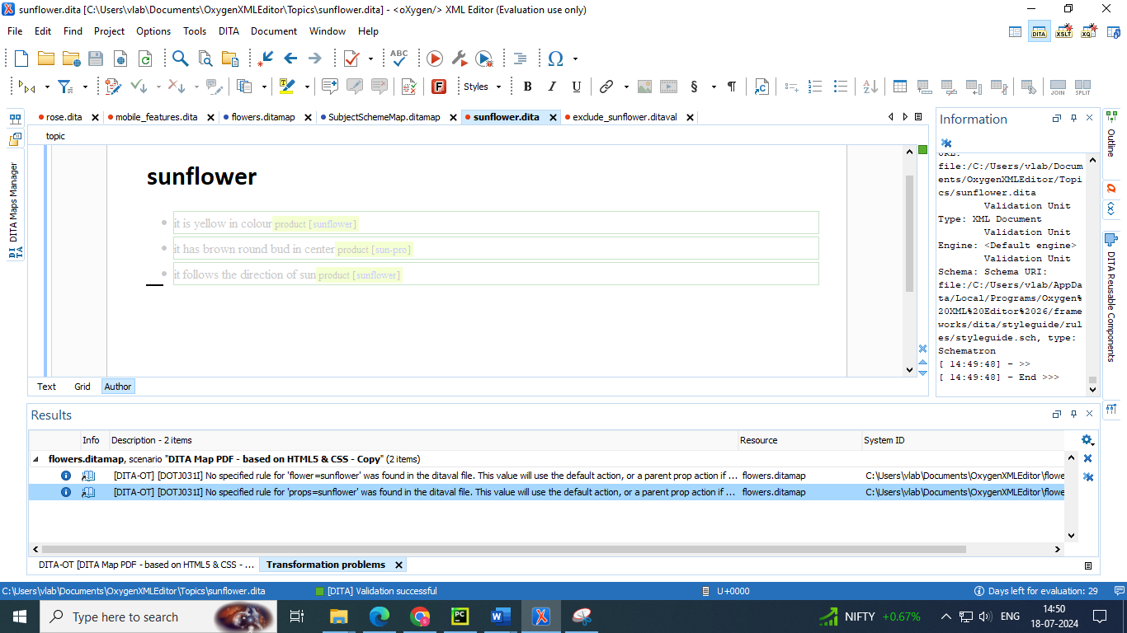

* To make only the subcategory attribute to exclude change the “val” value with the sun-pro

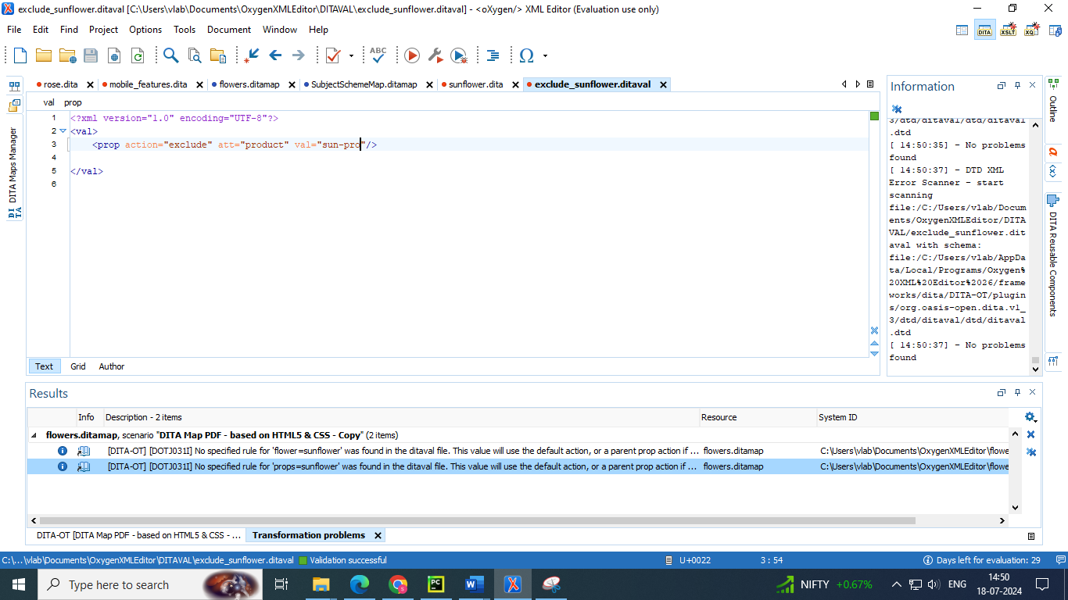

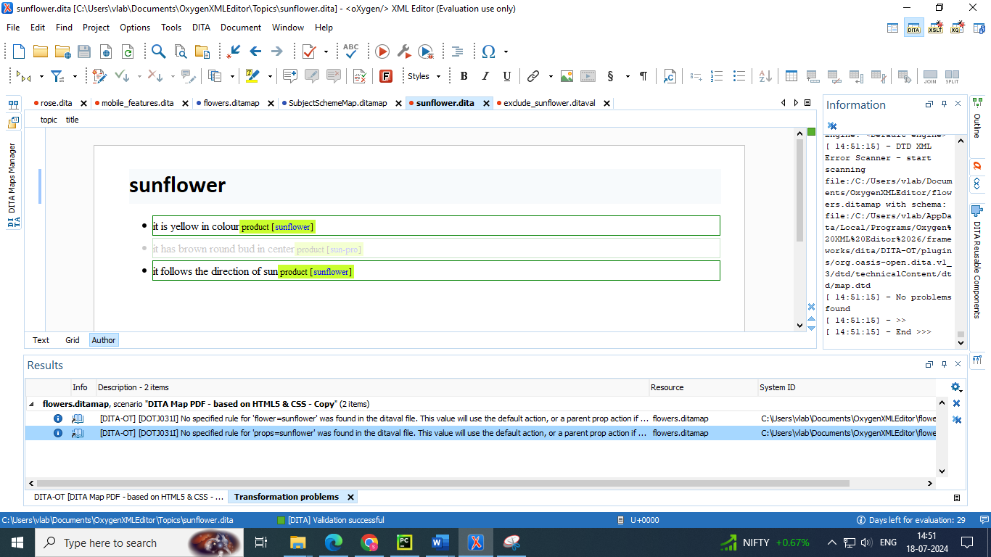

**Deleting the profiling attributes using Subject scheme maps**

* Add one more binding block in subject scheme map 🡪 give name of the attribute you want to delete in attributedef column 🡪 leave the bind attribute value blank

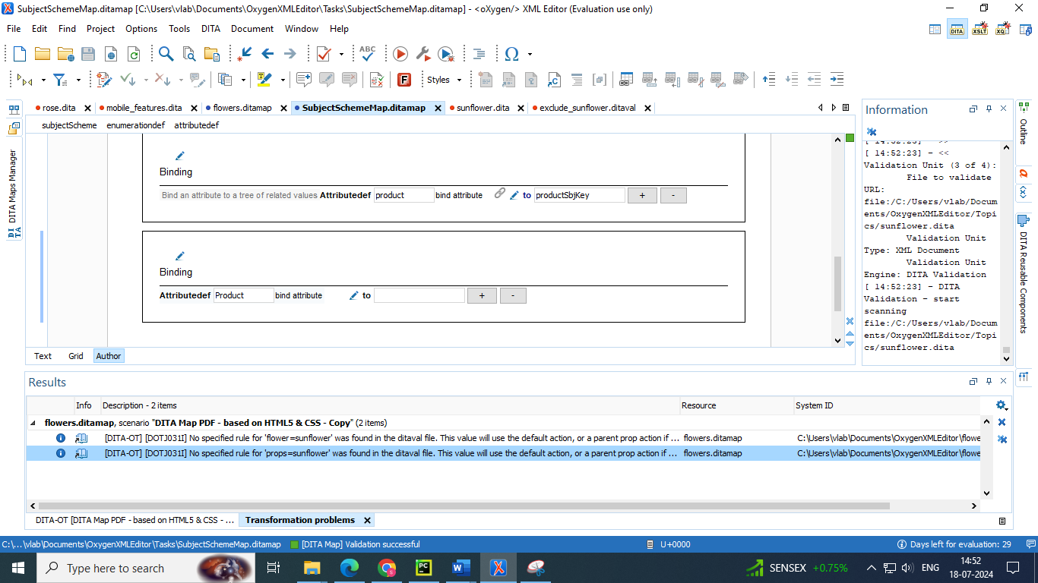

* Go to dita map in dita map manager 🡪 right click 🡪 edit properties 🡪 profiling 🡪 you will observe that that the mentioned attribute in binding block is deleted

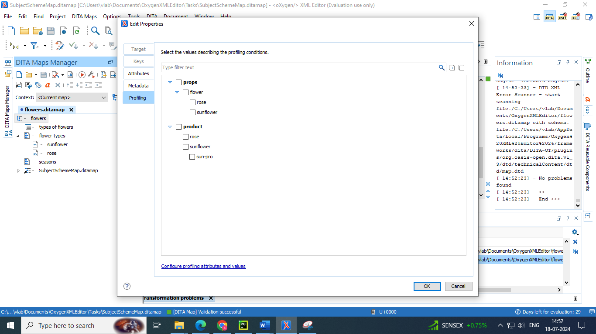

**5. Key scopes**

DITA 1.3 includes the possibility of using a concept called Key Scopes (or scoped keys). It allows you to reuse a topic in multiple places within the same DITA map(on page 3419), but with slightly different content in each instance.

**Key Scopes Use-Case**

Suppose that you develop a software product and you have a topic in your user guide that explains how to install your product on a Windows operating system. Suppose that the steps are exactly the same for installing it on Linux and the only difference is the name of the operating system. Therefore, it would be helpful if you could reuse the exact same content in two different topics, but with the name of the operating system different in each instance. In DITA 1.2, this is not possible since keys can only be resolved to a single value. However, with the DITA 1.3 Key Scopes mechanism, you can define multiple values for the same key depending on the context.

● All key definitions and key references exist within a key scope.

● Each key scope has its own key space that is used to resolve the key references that occur within the scope.

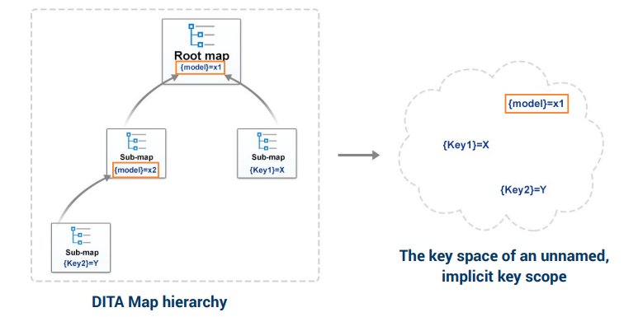

● Key scopes (DITA 1.3+) enable map authors to specify different sets of key definitions for different map branches.

● A key scope is defined by a or element (including specializations) that specifies the @keyscope attribute.

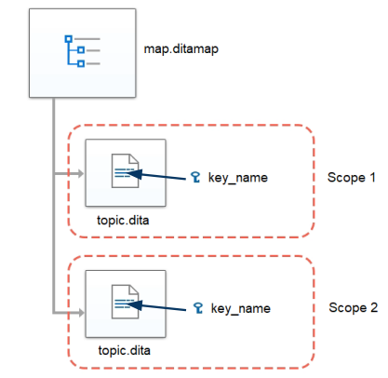

**How to Use Key Scopes in Oxygen XML Editor**

To use DITA 1.3 key scopes in Oxygen XML Editor, follow these steps:

1. Define the to be used in multiple places within your DITA map.

2. For each particular topic that contains the keys, define the key scopes:

a. Right-click the topic in the DITA Maps Manager and select Edit properties.

b. In the Keys tab enter a value (or multiple values) in the Key scopes field.

c. Click OK to save your changes.

3. Save the DITA map.

**Result:** In the DITA Maps Manager you can now see the key scopes in brackets and when you open each topic reference.

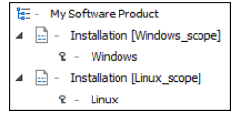

The content will also be expanded in Author mode according to the context of the key scope you defined for that particular topic. Also, when you transform the DITA map, the scoped keys will be reflected in the published content.

**Steps to use the key scopes**

* Create a topic inside “sunflower” topic by appending a new child

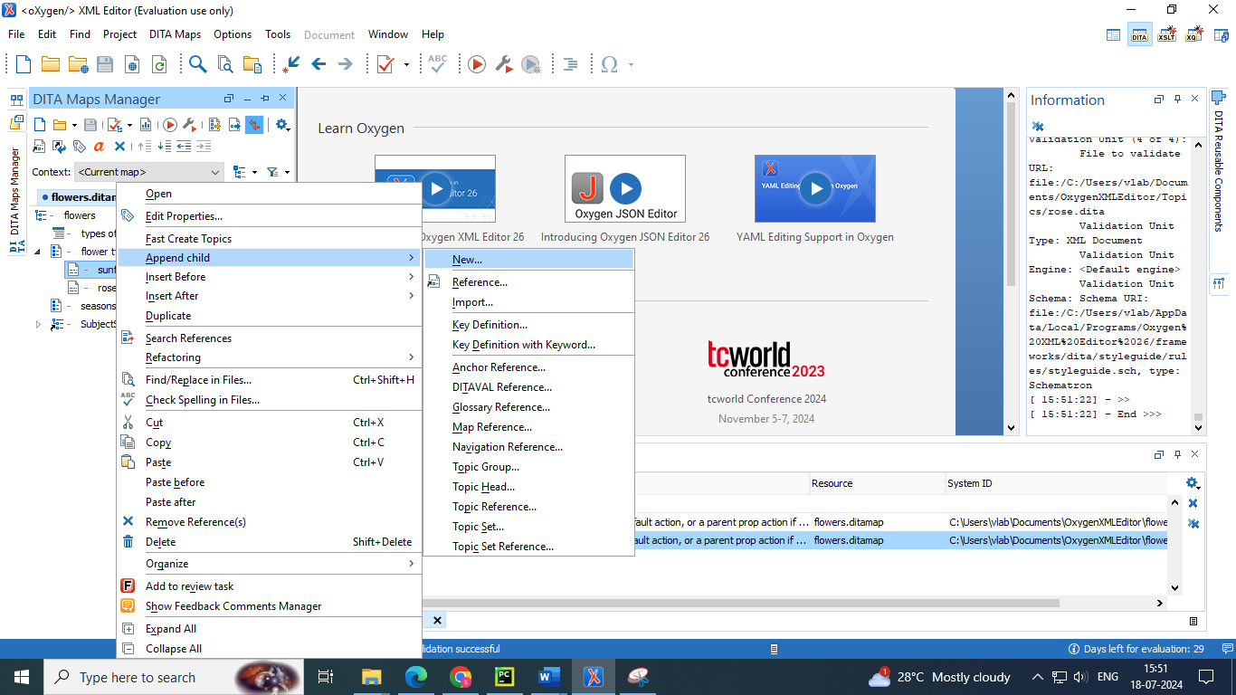

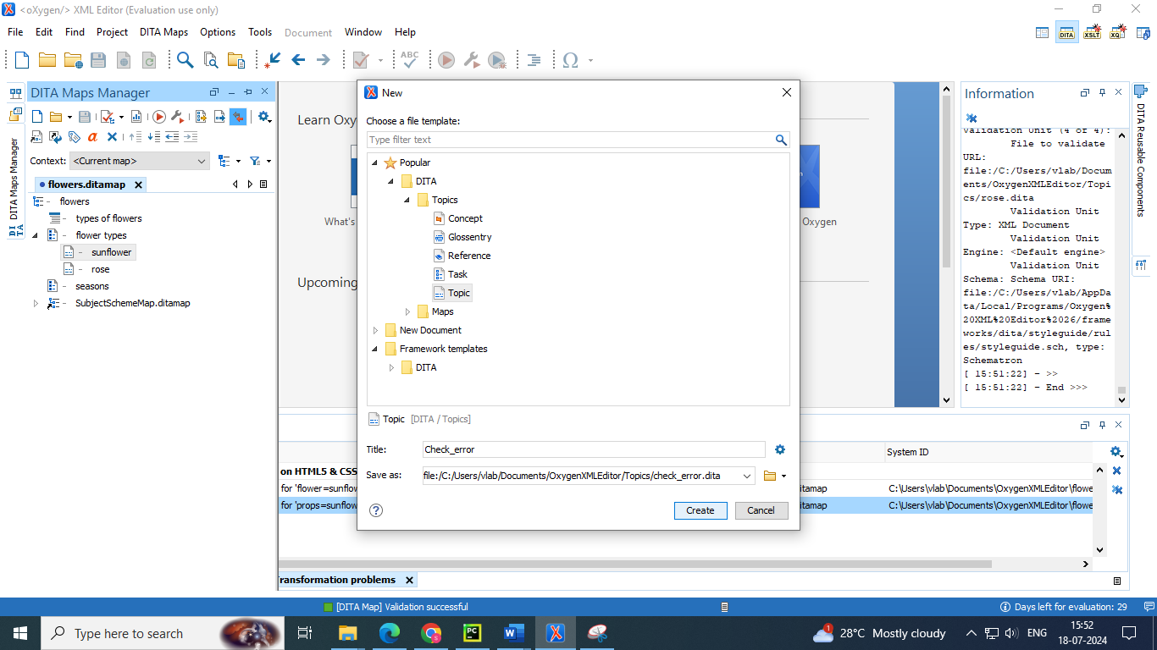

* Add key definition for an image to the created topic recently by appending as a child

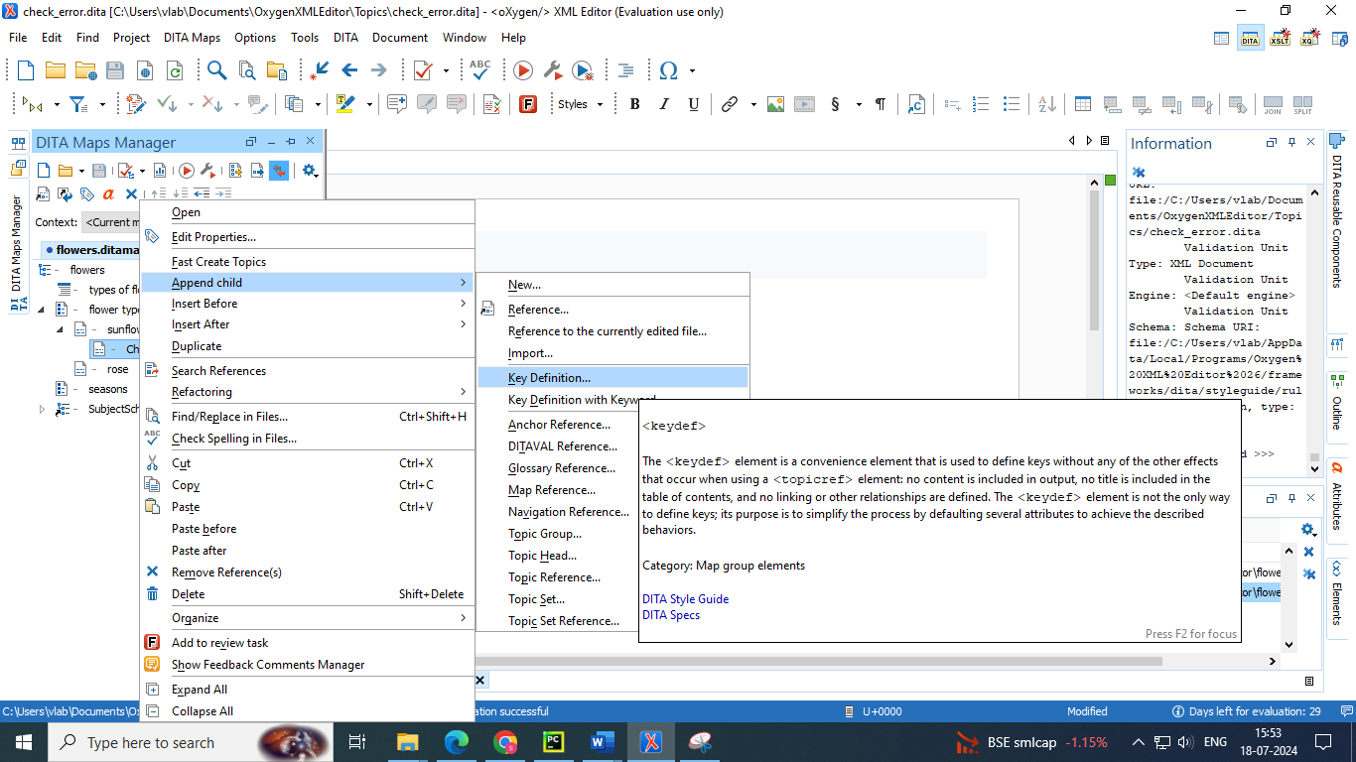

* Select the target of the key added in Target sub section and give a name to the key in Keys section

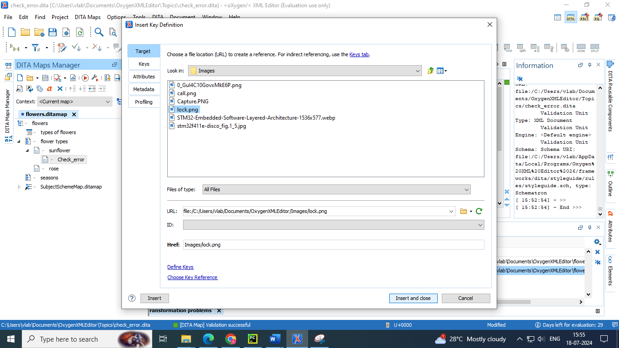

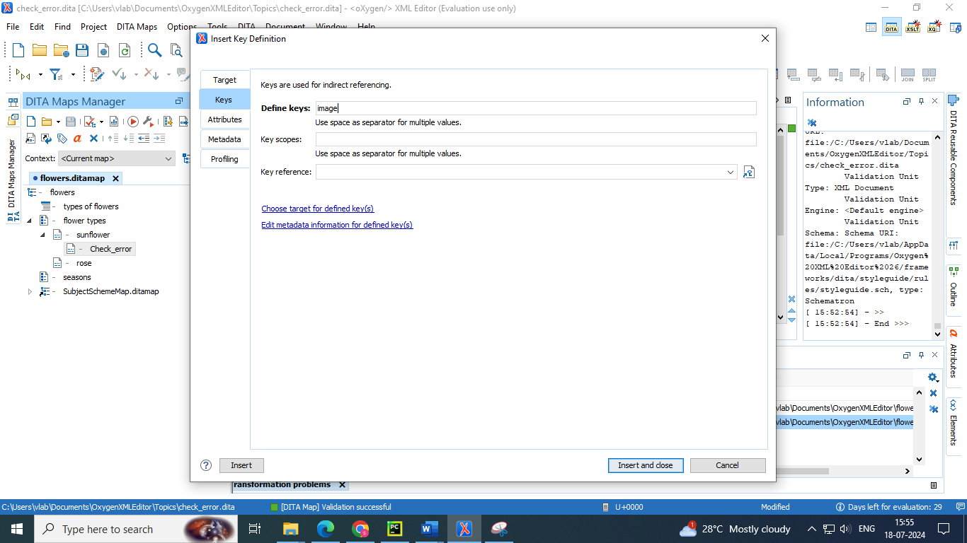

* Insert another key to same topic with the keyword

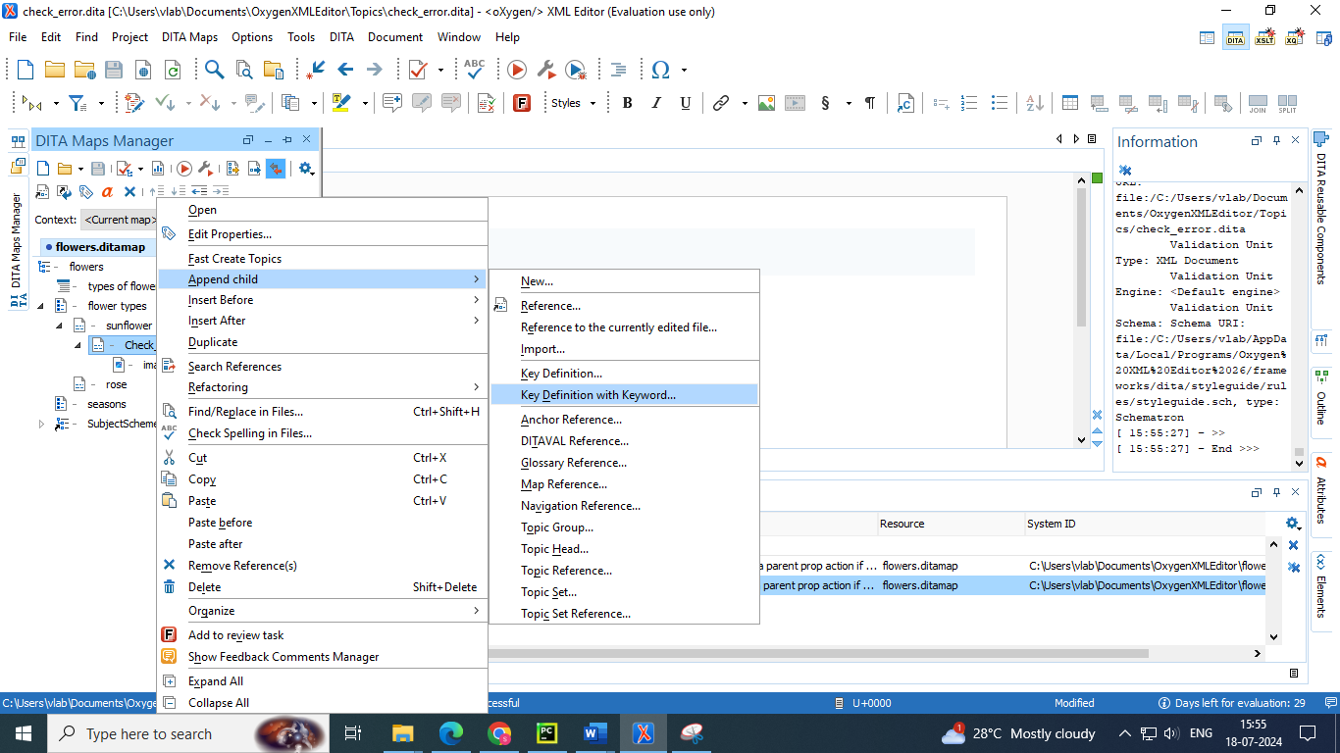

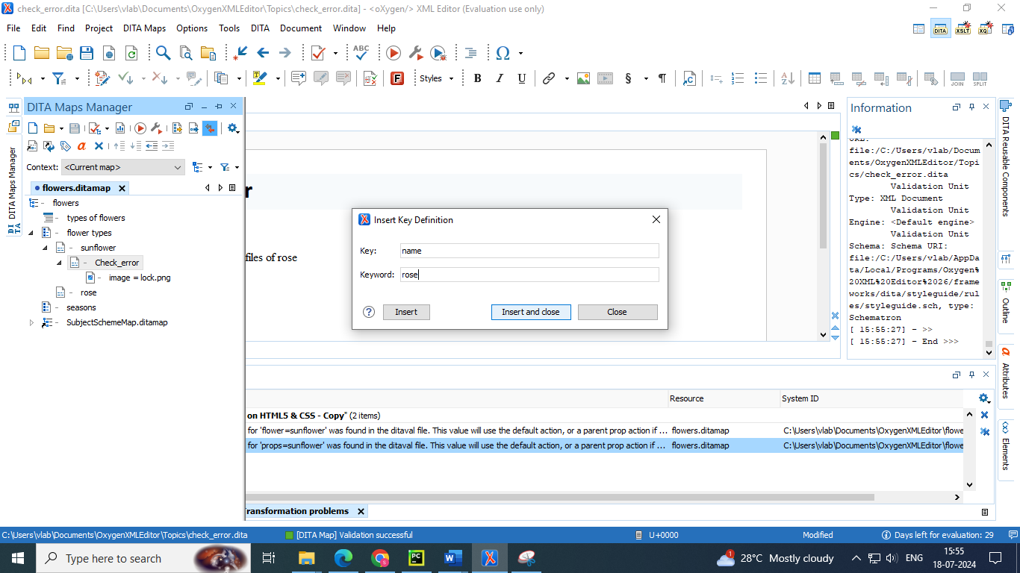

* Now insert those keys in the topic content in author mode by right using keys section in reuse content option 

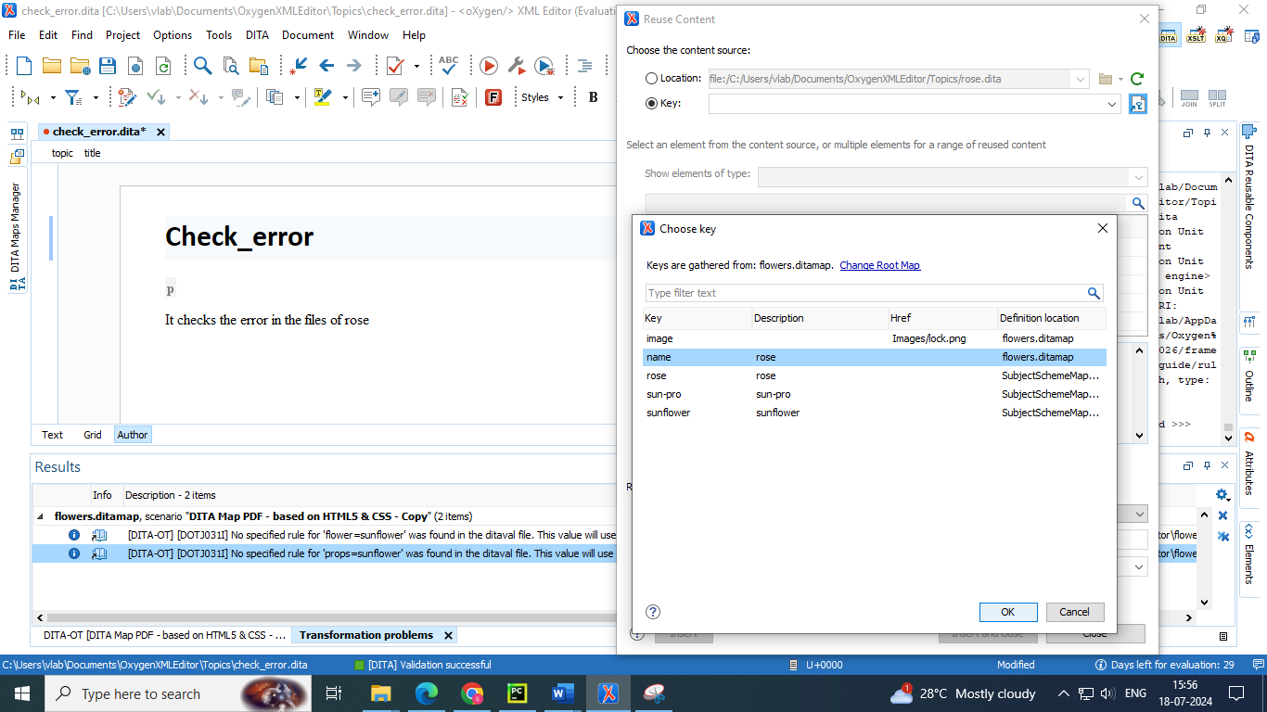

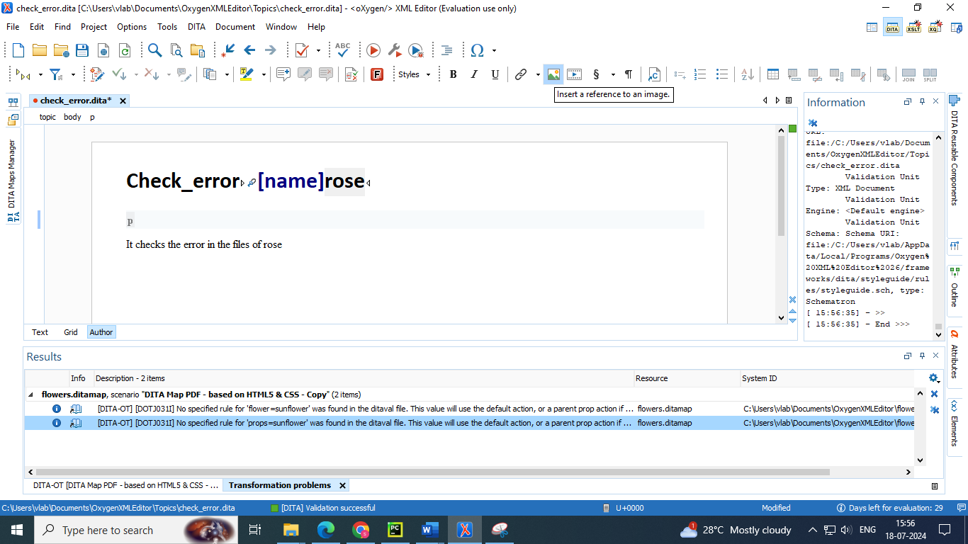

* Add the image key reference by using insert image reference in menu bar 

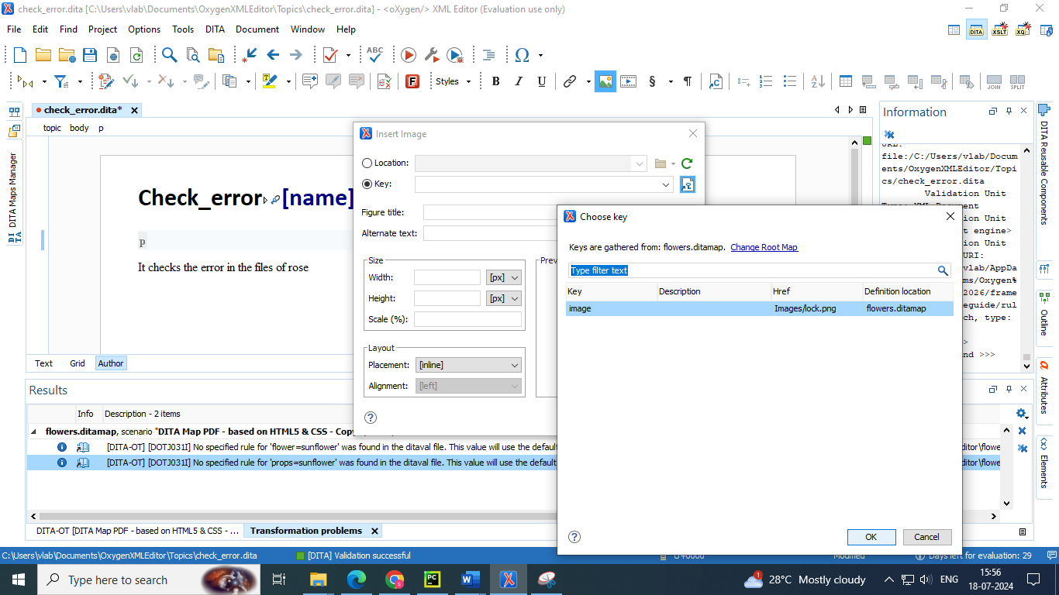

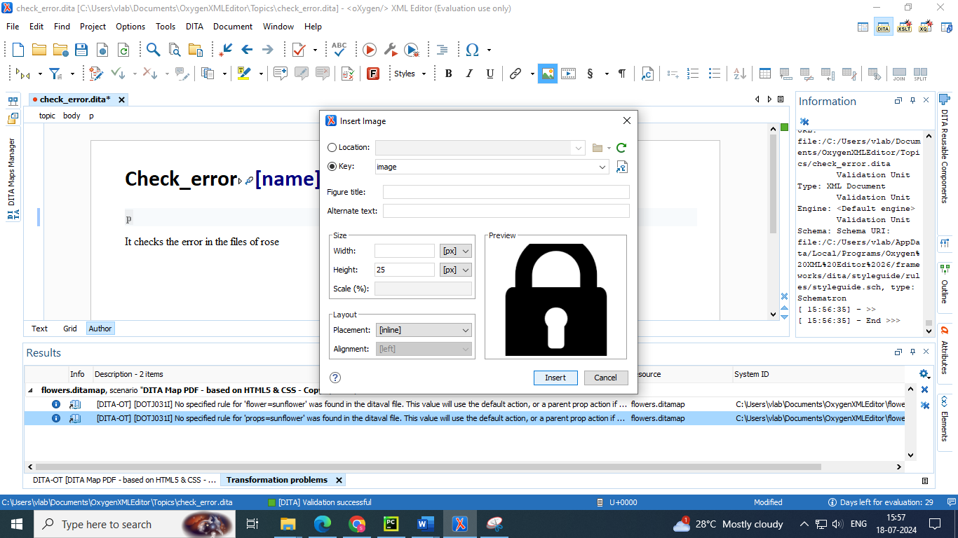

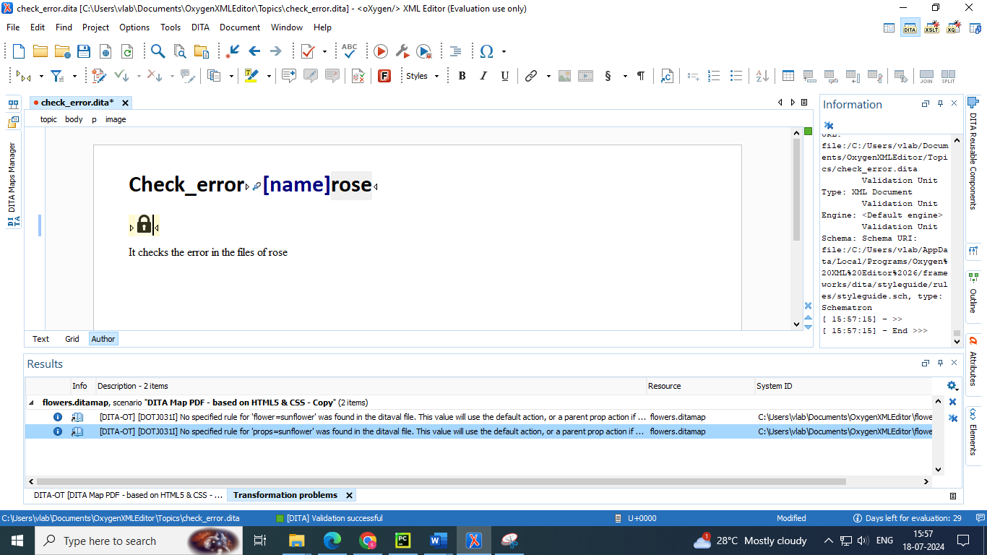

* Now copy those created topic and keys in sunflower topic to the “rose” topic also

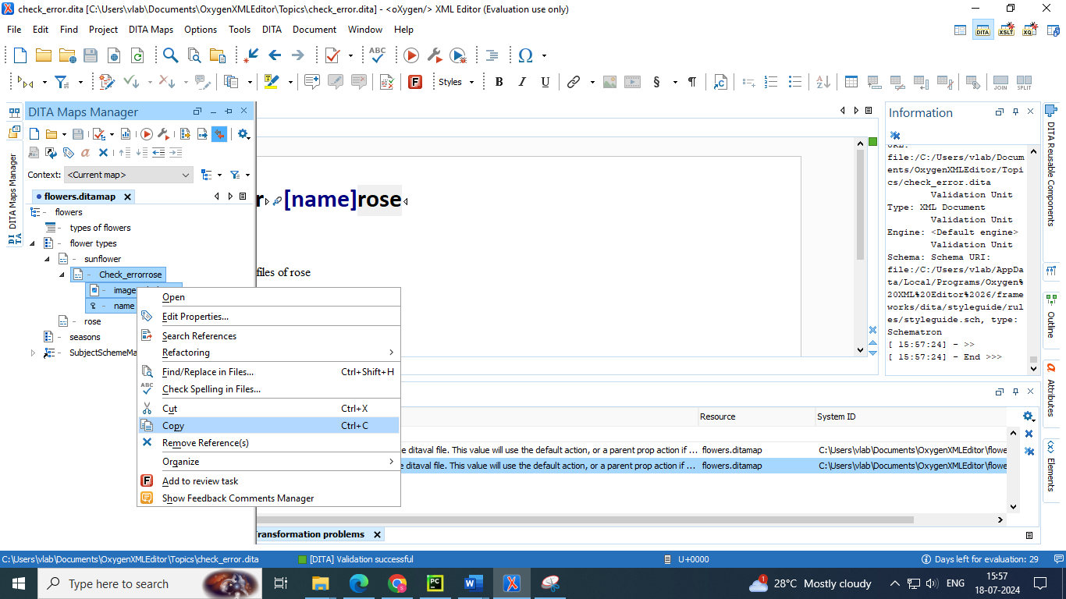

* Now edit the keys properties of image to other image and keyword to sunflower

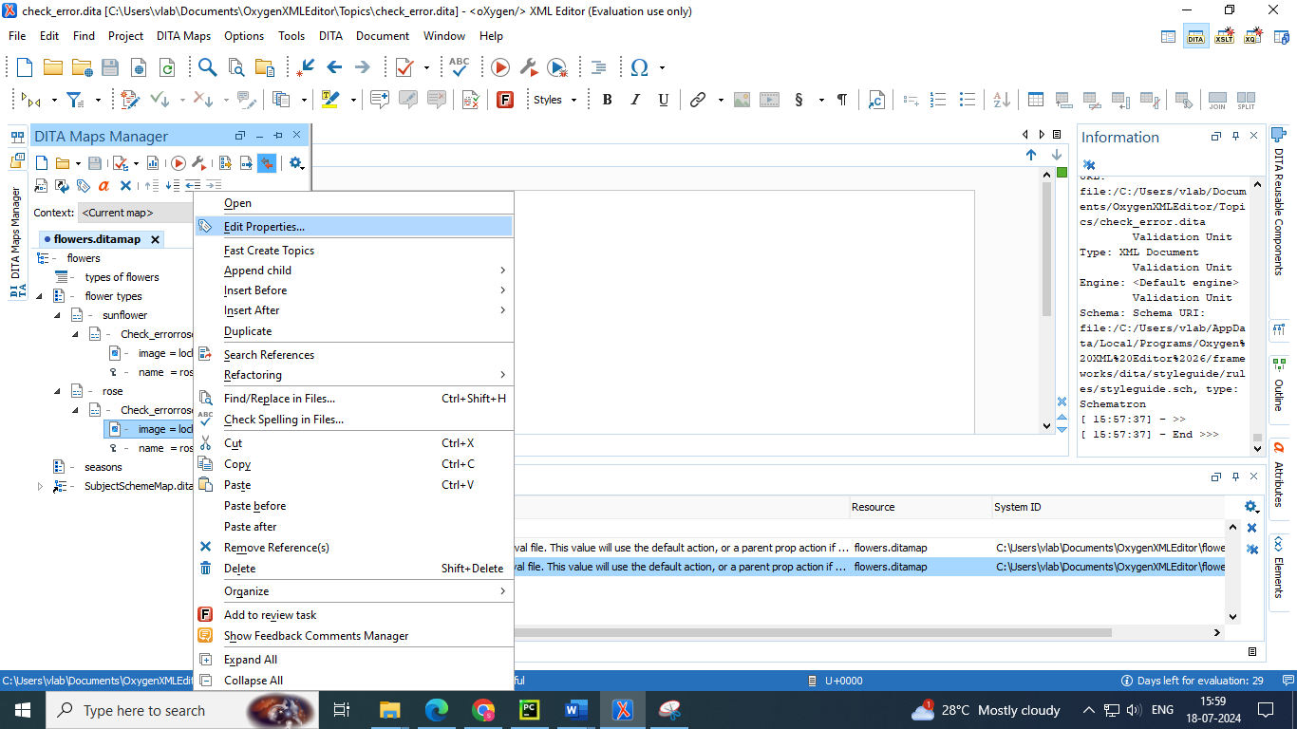

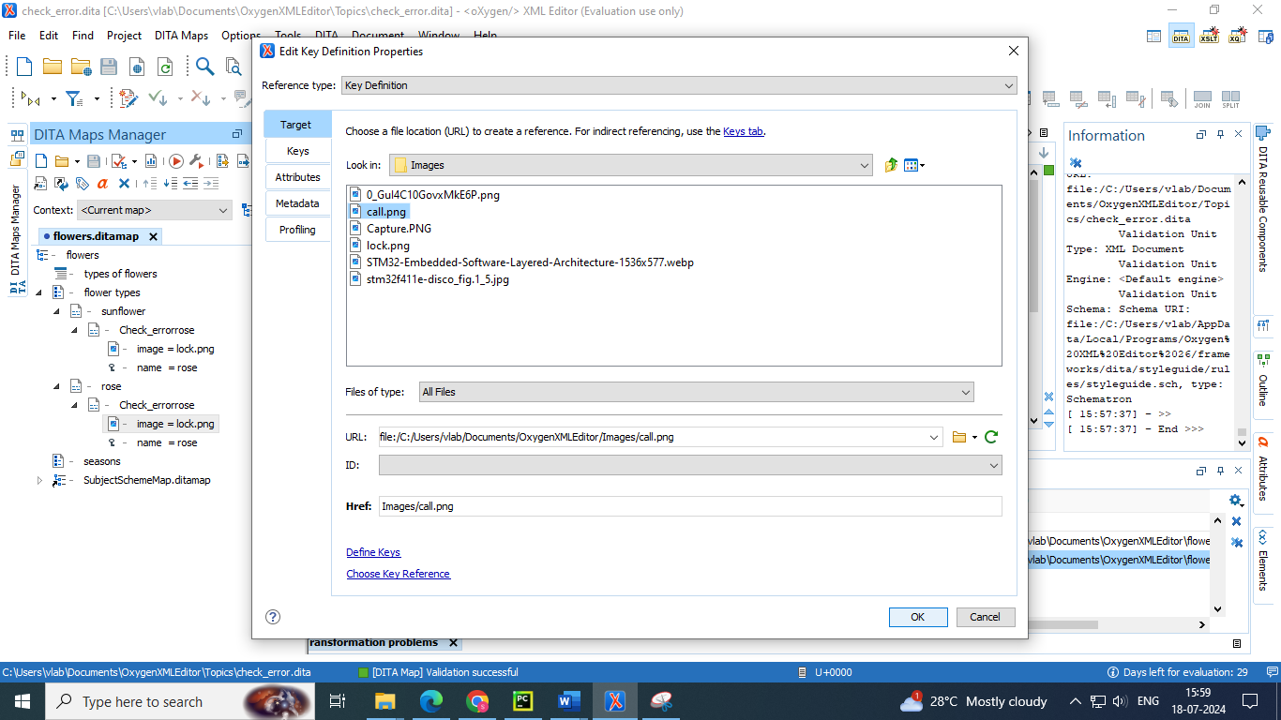

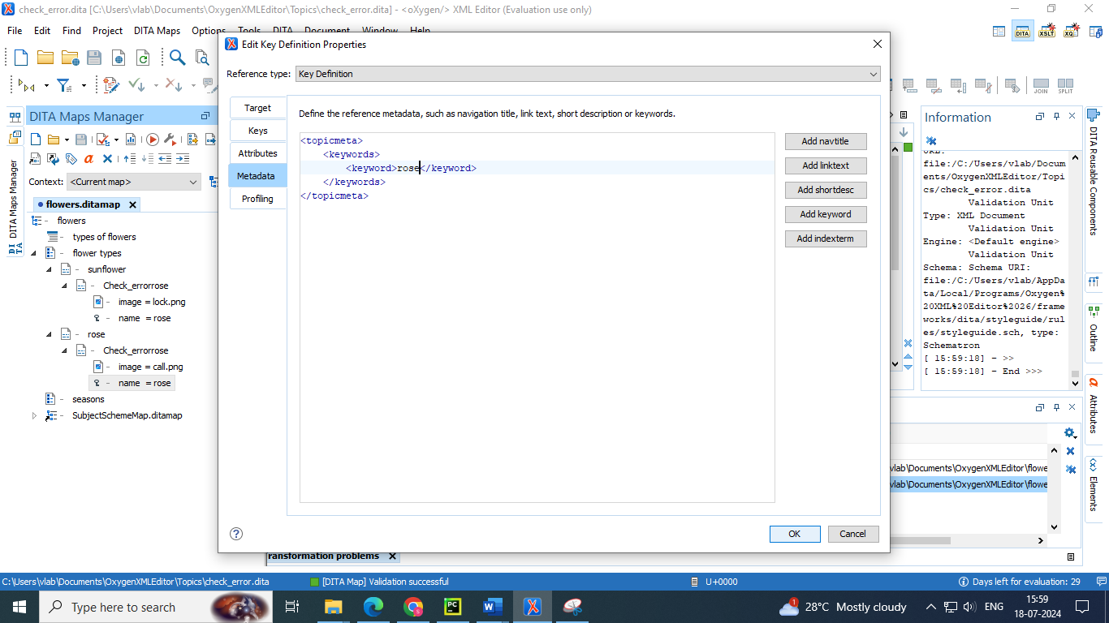

**Fig : changing the keyword value to rose in metadata subsection**

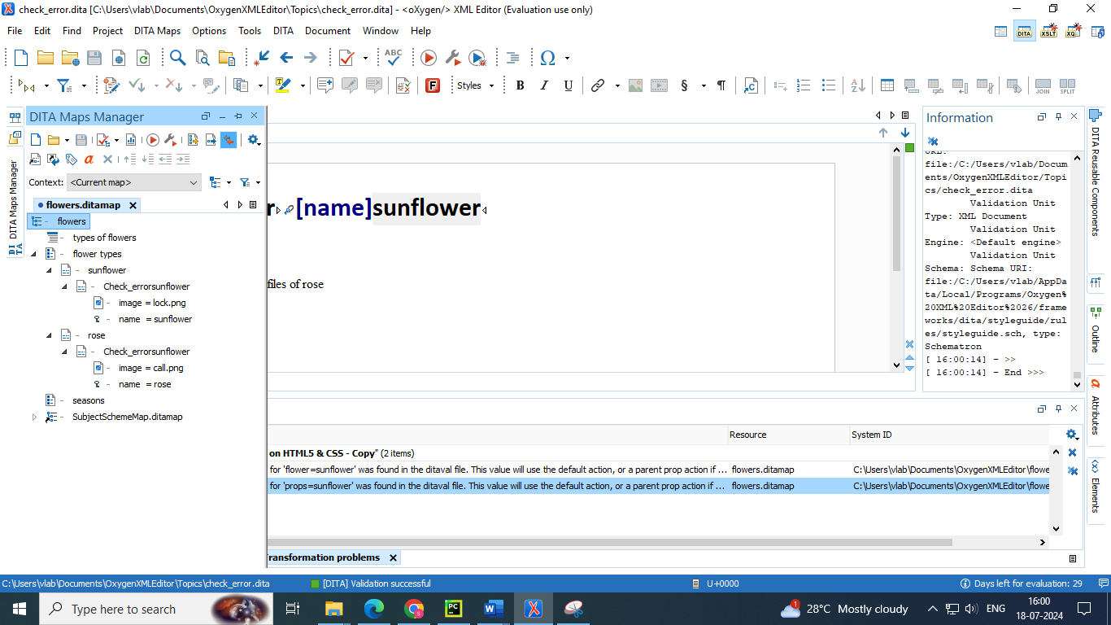

* But in the above picture we observe that both the topics have the name sunflower 🡪 reference created to sunflower for both topics
* To change it we need to create a key scope for both so that a single topic can be used as references for both the topics “sunflower” and “rose”
* Go to common topic created 🡪 edit properties 🡪 go to keys section 🡪 give a different name to both topics appended in keyscope section 🡪 it will create two separate references with single topic

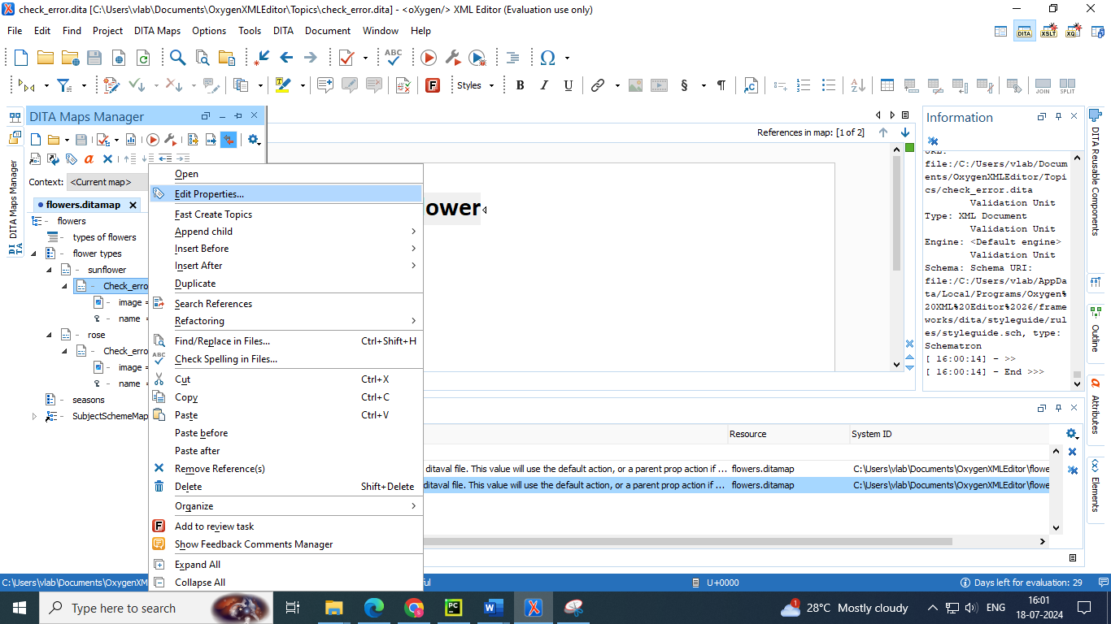

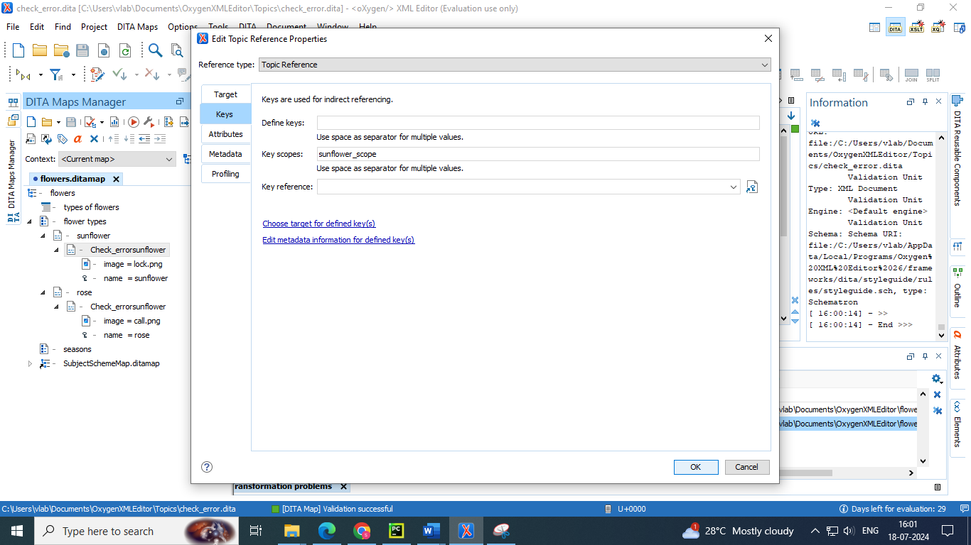

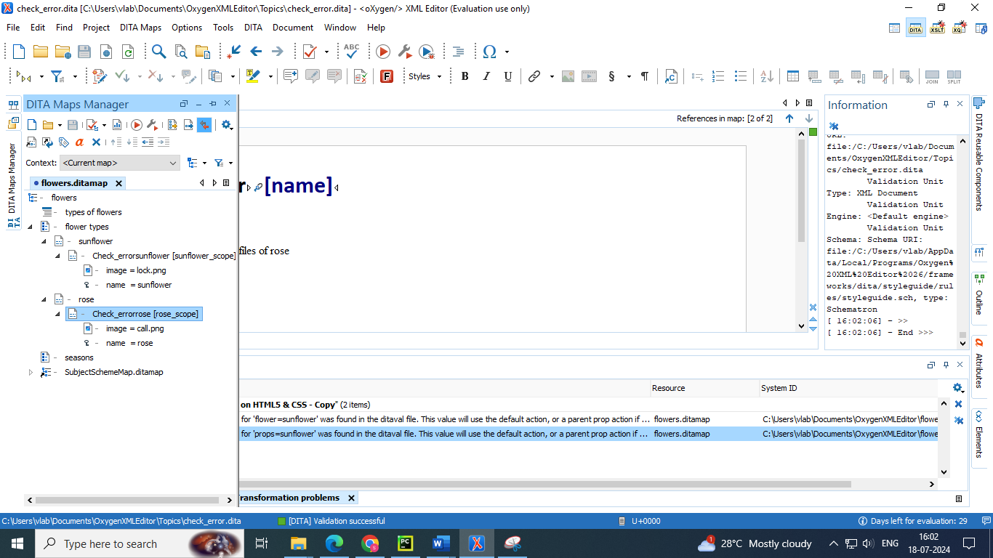

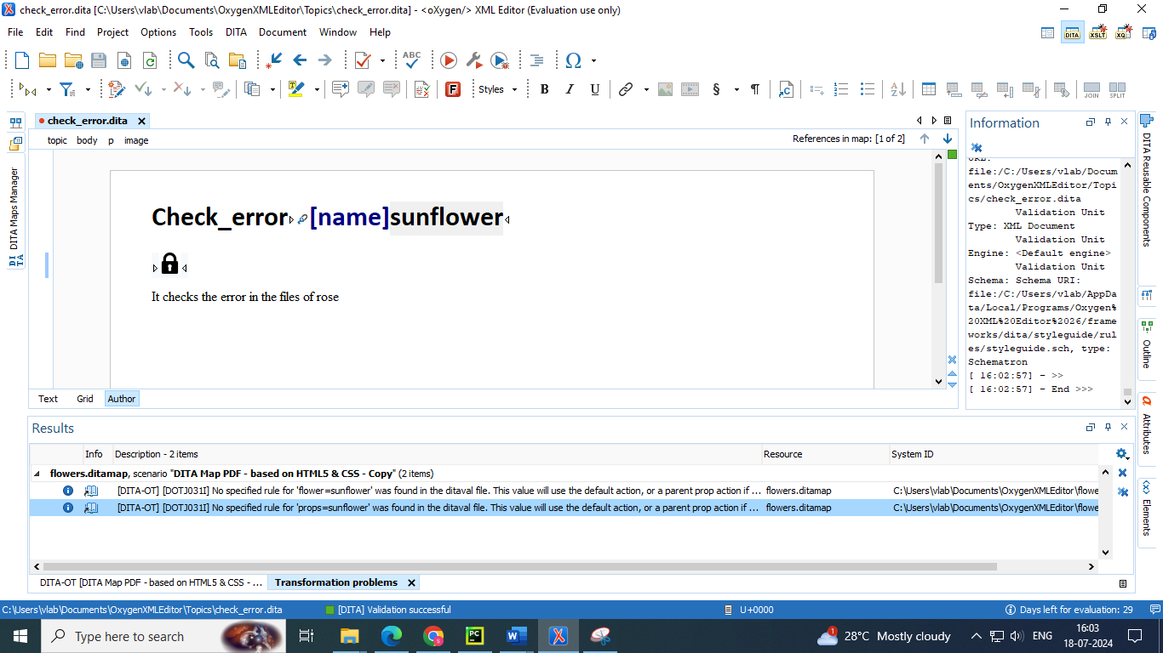

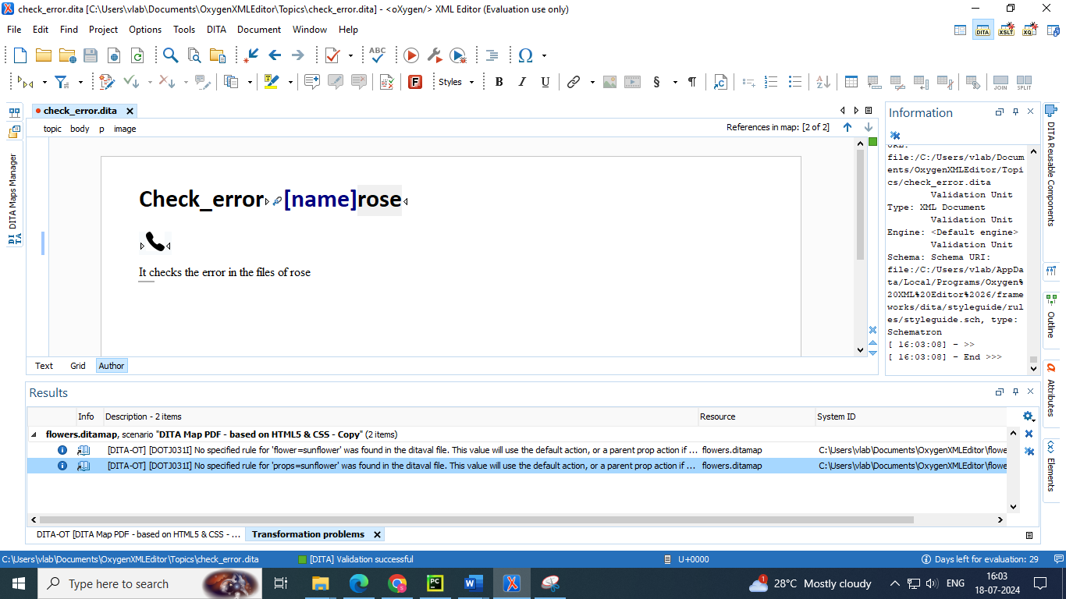



**Fig : here we can observe that a single topic has 2 references**

**6. Branch filtering**

DITA 1.3 allows you to use a mechanism called Branch Filtering that enables you to set filtering conditions for specific branches of a DITA map(on page 3419). This makes it possible for multiple conditional profiles to be applied within a single publication, each time with a different filter.

**Branch Filtering Use-Case**

Suppose that you sell two models of a mobile phone and you need to create a brochure for each model. You want both brochures to have the same structure and most of the content is the same for both brochures. The only differences are in the values for certain details (for example, the model name, size dimensions, battery life, etc.) Therefore, it would be helpful if you could use the same topic and reference it twice in the same map, with each reference using different filtering conditions. In DITA 1.2, this is not possible since you can only apply one DITAVAL filter to a map. However, with the DITA 1.3 Branch Filtering mechanism, you can reuse content multiple times within the same map, each time using different filters.

● Until DITA 1.3, only one DITAVAL filter could be specified for the map to be published.

● The conditions specified in the DITAVAL file were applied globally.

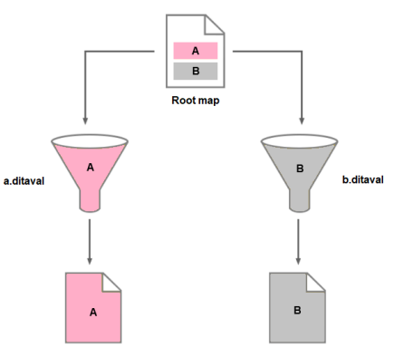

● The branch filtering mechanism (DITA 1.3+) enables map authors to set filtering conditions for specific branches of a map.

● A branch can correspond to both topic and map references.

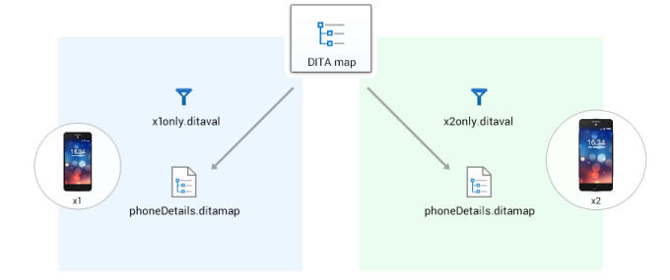

● Branch filtering is based on the element, which references the DITAVAL filter to be be used when processing a map or map branch.

● The location of the element determines the content to which filtering conditions are applied.

● As a rule, the filtering conditions are applied to:

1. The parent element that contains the element.

2. The child elements of the parent (the siblings of the ).

3. All resources that are referenced by the parent element or its children.

**How to Use Branch Filtering in Oxygen XML Editor**

To use DITA 1.3 branch filtering in Oxygen XML Editor, follow these steps:

1. The support for DITA 1.3 must be enabled in the DITA preferences page

2. Assuming you have already defined your profiling attributes create a DITAVAL filter file

3. Insert a reference to the DITAVAL filter file in the DITA map:

a. Right-click the DITA map reference in the DITA Maps Manager and select Append Child > DITAVAL Reference.

b. Select the DITAVAL file.

c. Click Insert and Close.

4. Save the DITA map.

**Result**: You can now see the ditaval files referenced in the DITA Maps Manager and when you transform the DITA map, filtered content will be reflected in the published output.

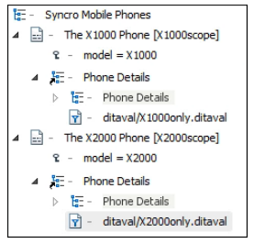

**Steps to apply branch filtering**

* Create a topic named “colour” and add both profiling attributes of “rose” and “sunflower”

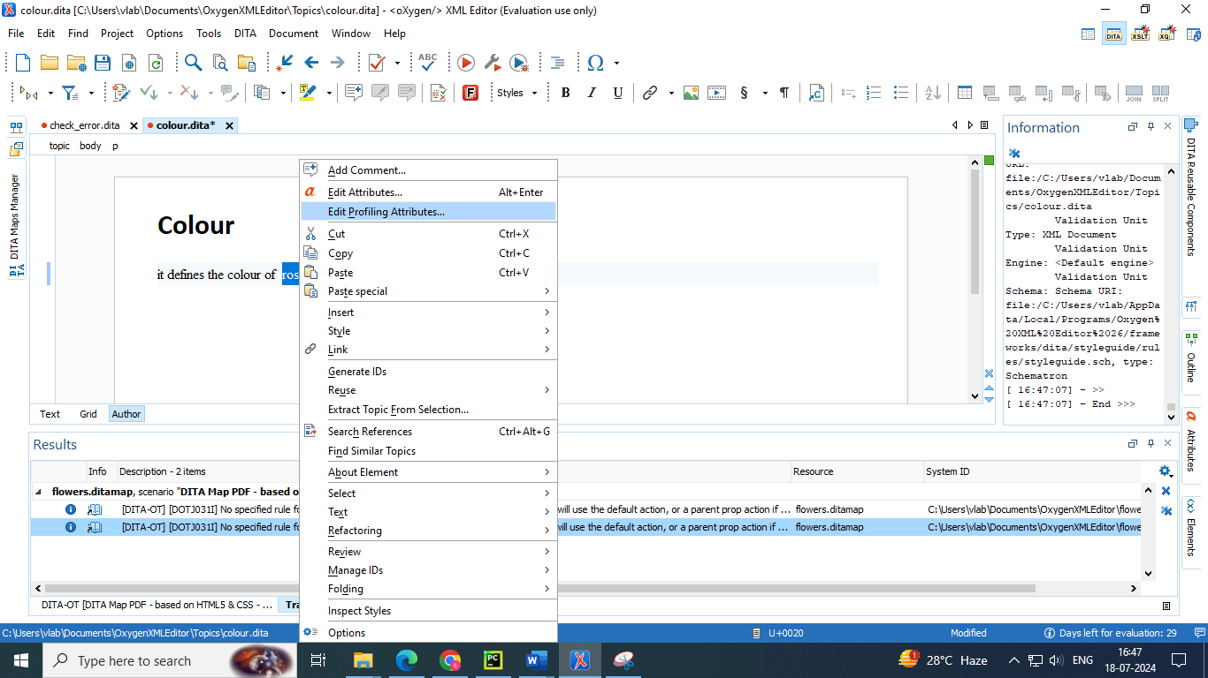

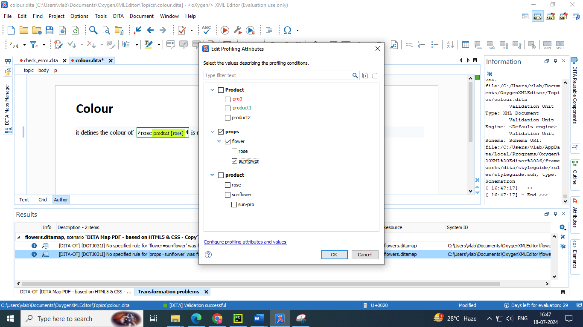

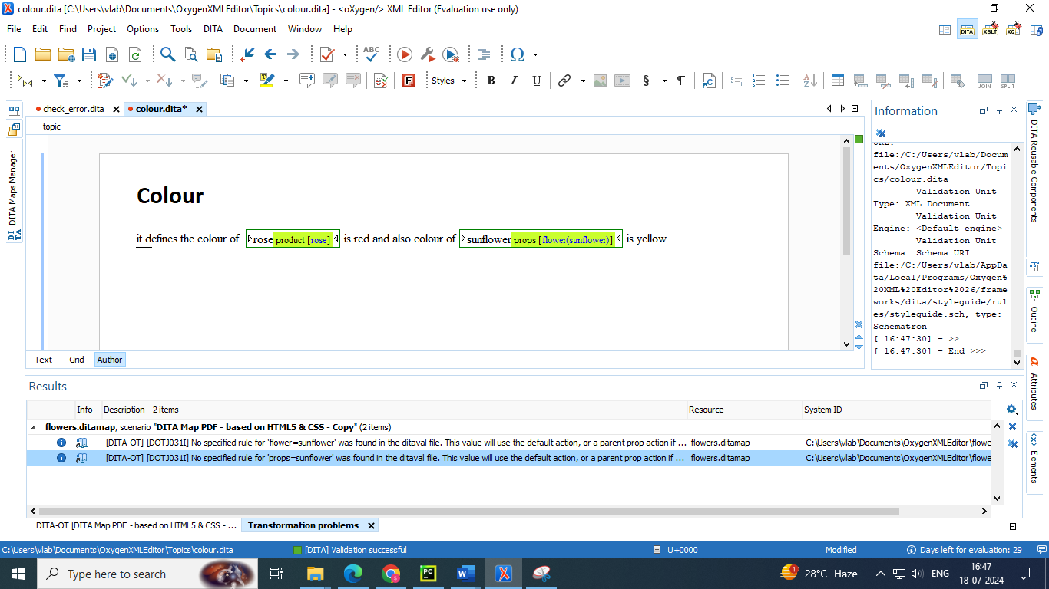

* Add the colour topic as a child to both topics “rose” and “sunflower”

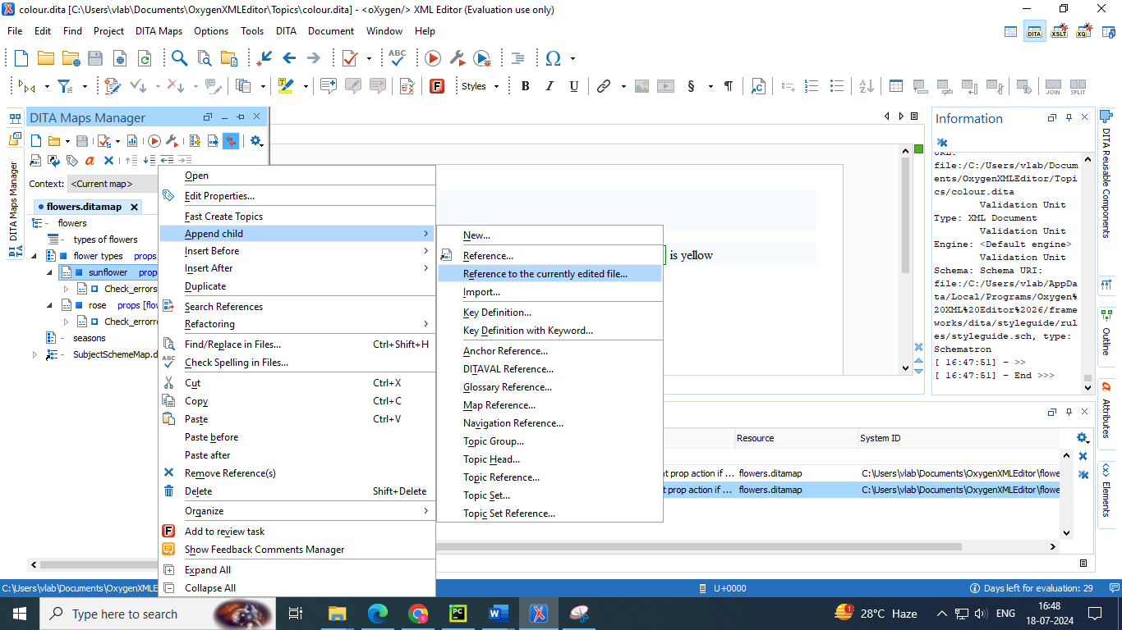

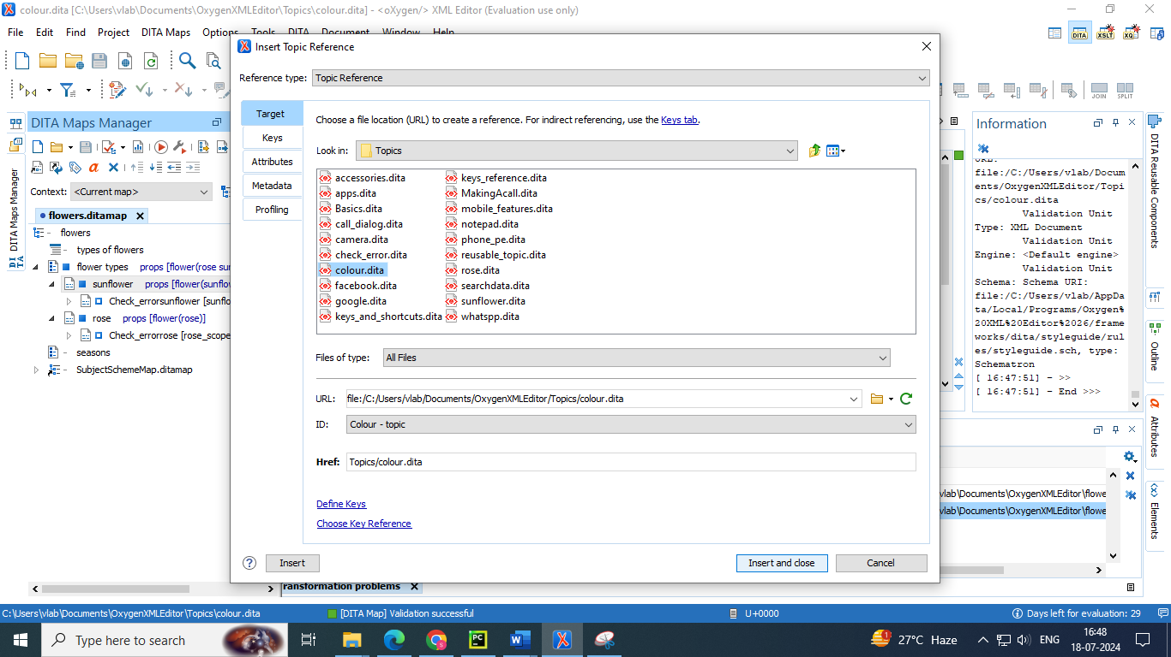

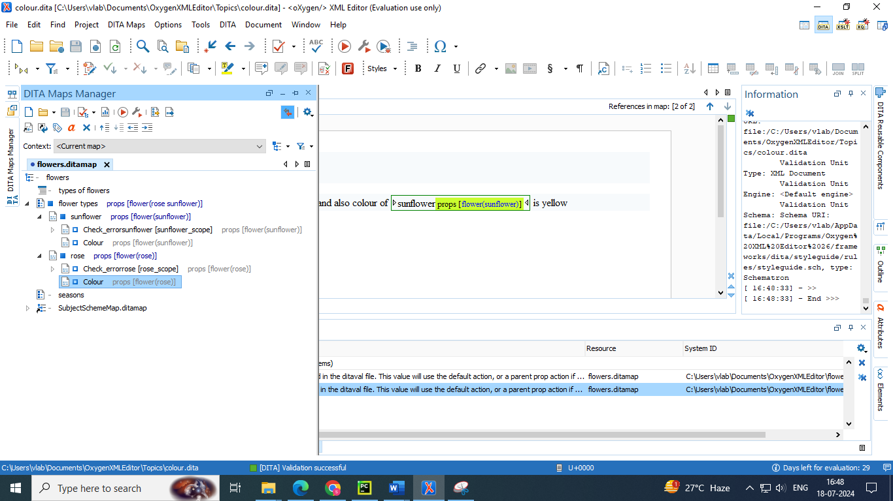

* Now add the ditaval reference inn both colour topics added for excluding sunflower content in rose topic and for excluding rose content in sunflower topic

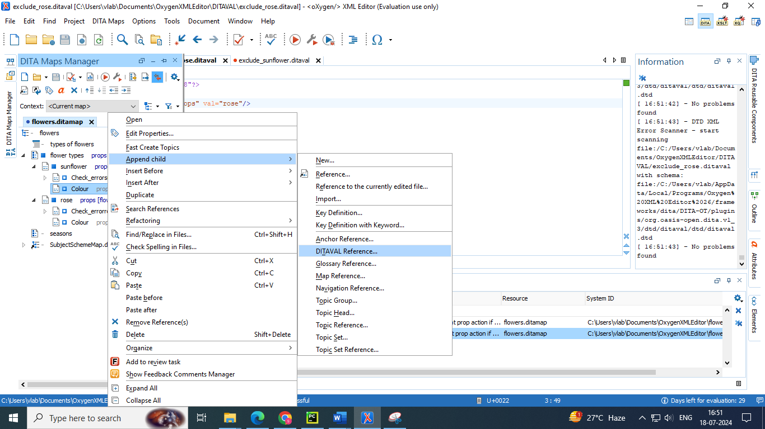

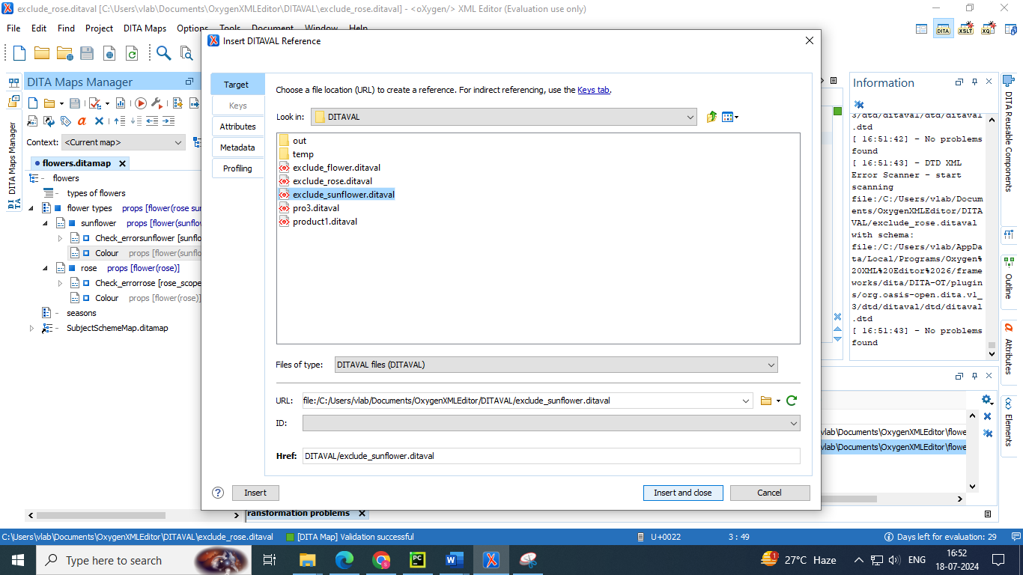

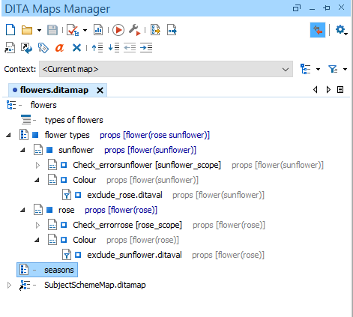

* Now publish the web page of the DITA map to view the effect of branch filtering

